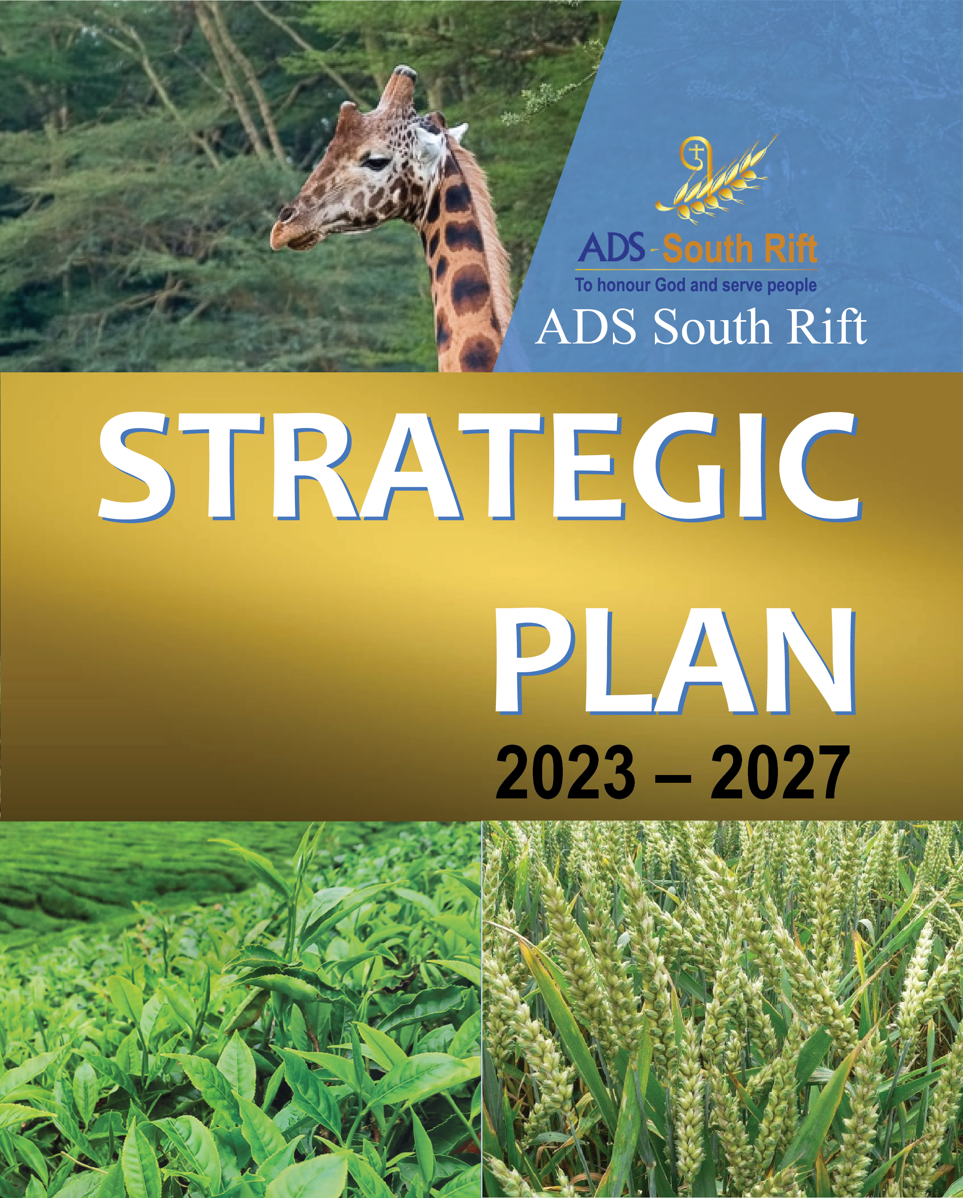
ADS SOUTH RIFT STRATEGIC PLAN
2023 – 2027

© Anglican Development Services South Rift (ADS SR)
August 2023

You may freely use sections of the material in this publication for academic, media and advocacy purposes with prior permission from the publishers. To do so, quotations from this report should have the source appropriately credited. To use this material for commercial purposes, you must request for written permission from the publisher.

Published by:
Anglican Development Services (ADS-South Rift)

For comments or enquiries, contact:
Executive Director
Anglican Development Services (ADS-South Rift)
P.O. Box 678 Kericho
info@adssouthrift.org
https://www.adssouthrift.org

Photos by: ADS South Rift

Concept: Graphic Design/Layout
Maglopa Talents Ltd
Tel: 0711990987

Printed by:

TABLE OF CONTENTS

ABBREVIATIONS iv
FOREWORD BY CHAIRMAN v
MESSAGE FROM THE EXECUTIVE DIRECTOR viii
EXECUTIVE SUMMARY ix

Chapter 1 1
INTRODUCTION 1
1.0 Introduction 1
1.2 Strategic Planning Rationale 2

Chapter 2 3
REVIEW OF 2017-2020 STRATEGIC PLAN 3
2.0 Lessons from the previous strategic plan (2017- 2020) 3

Chapter 3 9
SITUATIONAL ANAYISIS 9
3.0 Situation analysis 9
3.1 PESTLE (Political, Economic, Social Technological, Ecological) 10
3.2 SWOT Analysis 13
3.3 Stakeholder Analysis 14

Chapter 4 16
STRATEGIC ISSUES FROM 2017-2020 STRATEGIC PLAN 16
4.0 Strategic Issues 16

Chapter 5 18
NEW STRATEGIC DIRECTION 18
5.0 New Strategic Direction Error! Bookmark not defined.
5.1 Vision 18
5.2 Mission 18
5.3 Core Values 18
5.4 Conceptual Framework 19
5.5 Pillars 20

Chapter 6 35
IMPLEMENTATION 35
6.0 Implementation 35

Chapter 7 36
RESOURCE MOBILIZATION AND FINANCIAL PROJECTIONS 36
7.0 Resource Mobilization and Budget Summary Error! Bookmark not defined.
7.1 Human Resources 36
7.2 Staff Capacity Requirements 36
7.3 Organizational and Culture Change 37
7.4 Implementation 37
7.5 Financial Projections and Budget Summary 37

Chapter 8: 38
RISK ANALYSIS AND CONCLUSION 38
Conclusion 38

ANNEXES 40
Annex 1(a): ADS Southrift Governance Structure 40
Annex 1(b): ADS Southrift Organizational Structure 41
Annex 2: Annual Operational Plans 42
Annex 3: ADS Southrift Total Estimated Cost in Kenya Shillings 60

List of Tables

Table 1: Results of the Review of 2017- 2020 Strategic Plan 5
Table 2: PESTLEP Analysis Results 10
Table 3: SWOT Analysis Results 13
Table 4: Stakeholder Analysis 14
Table 5: ADS South Rift Conceptual Framework 19
Table 6: Community Development Pillar 1: Summary of Strategic Objectives, Results and Strategic Initiatives 21
Table 7: Pillar 2: Organization Sustainability & Transformation 29
Table 8: Pillar 3: Property and Investment 32
Table 9: 2023 Annual Operation Plan 42
Table 10: Annual Operational Plan 58
Table 11: Annual Operational Plan 2023 63

ABBREVIATIONS

ACK - Anglican Church of Kenya
ADS-K - Anglican Development Services of Kenya
ADSSR - Anglican Development Services South Rift
CBDs - Community Based Distributors
CCMP - Church and Community Mobilization Process
CHVs - Community Health Volunteer
CHS - Core Humanitarian Standards
CIDP - County Implementation Development Plans
FGM - Female Genital Mutilation
FFS - Farmer Field Schools
GBV - Gender Based Violence
HCBC - Home and Community Based Care
IGA - Income Generating Activity
KCDT - Kericho Community Development Trust
LARC - Long Acting Reversible Contraception
OCA - Organization Capacity Assessments
OVC - Orphans and Vulnerable Children
PLHIV - Persons Living with HIV
PSS - Psychosocial Support
NCPWD - National Council for Persons with Disability
MEL - Monitoring, Evaluation and Learning
MIYCN - Maternal, Infant and Young Child Nutrition
RDQA - Routine Data Quality Assessments
SBC - Social behaviour change
SRH - Sexual and Reproductive Health
TCS - Treatment Care and Support
TWG - Technical Working Group
TOT - Training of Trainers
VSLA - Village Savings and Lending Association

FOREWORD BY CHAIRMAN

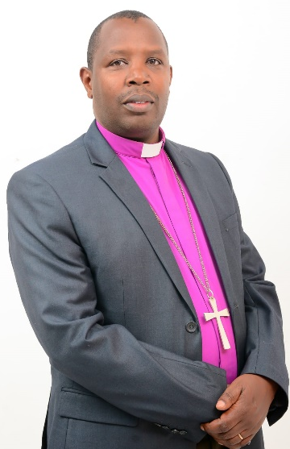
I wish to express my gratitude to the Almighty God for granting me the privilege and the honour to preside over the development of the ADS South Rift 2023-2027 Strategic Plan. As we stand on the threshold of a new 5 year dispensation, it is with a sense of anticipation and determination that I present this report, outlining plans and the roadmap we will follow to achieve them.

This is our second strategic plan since inception of ADS South Rift. This far we have seen the hand of our God in the transformation of thousands of lives and Christ’s witness in our development agenda within the Diocese of Kericho and the ADS South Rift Region. Gladly, our partnership base has grown with time thus enabling us address the community projects requiring our intervention. The increasing needs have prompted the necessity for new strategies towards greater resource mobilization for our projects as well as efficiently utilising the resources we have received to transform the lives of the communities within our jurisdiction.

Our vision remains steadfast – to be a catalyst for positive change, fostering sustainable development and improving the lives of communities around the South Rift region. Guided by this vision, our new strategic plan is designed to be more agile, responsive, and inclusive, enabling us to adapt to evolving challenges and opportunities.

We have taken time to deliberate on what and how we expect to achieve in the next 5 years. This is in line with the abundant life that is embodied in the Biblical text in the Book of John 10:10. We have faith in all those entrusted with responsibility that our vision will be fulfilled; that lives will be transformed and indeed the plan will enhance the preaching of the gospel of our Lord and Saviour Jesus Christ.

In this strategy we have developed 3 Pillars namely; Community Development, Institutional Sustainability and Transformation and Property and Investment. These pillars will be vehicles that will drive this strategy and ensure we are on course.

We are committed to creating innovative projects that address pressing challenges in our community, from climate change to poverty alleviation. Our plan emphasizes capacity building through education, training, and skill development, equipping people with the tools they need to drive their own progress and contribute to society.

Recognizing that collaboration is essential for meaningful change, we will actively seek out partnerships with governments, NGOs, businesses, and local communities. By pooling our resources, knowledge, and expertise, we can magnify our impact and achieve greater results.

Embracing innovation and leveraging cutting-edge technologies will be pivotal to our success. We will explore digital solutions and emerging technologies to create efficient and scalable solutions to address challenges in our context.

Our goal is to achieve tangible and measurable impacts in the communities we serve. We will regularly assess and report on our progress, holding ourselves accountable for the outcomes of our initiatives.

The world is ever-changing, and we must be prepared to adapt. Our plan emphasizes flexibility, allowing us to pivot in response to unforeseen challenges while staying true to our overarching vision.
In closing, our new strategic plan is not just a roadmap. It's a declaration of our unwavering dedication to creating positive change. As we embark on this journey together, I am confident that our shared passion, expertise, and commitment will lead us to achieve remarkable feats of sustainable development.

We call upon all our stakeholders, staff, communities, partners and the board to work together in faith, take bold action, with the love of God so as transform the lives of the people in ADS South Rift region. This will enable us to have a truly “Wholesome and dignified living’’ in the region. This is our prayer, “May your favour be on us, Lord our God; make our endeavours successful; yes, make our endeavour secure!’’ Psalm 90:17.

Finally, we wish to express our sincere gratitude to the entire technical team, headed by the Executive Director Mary Naikumi and our facilitator and Consultant Bwibo Adieri the Executive Director of ADS Kenya.

God bless you.

The Rt. Rev. Ernest Ngeno,
Chairman and Bishop of the Diocese of Kericho

MESSAGE FROM THE EXECUTIVE DIRECTOR


It is my pleasure to present our new Strategic Plan (2023-2027). While this plan steers our new direction for the next five years, it is important that it is understood as part of a trajectory, beginning with our longtime foundation in social transformation and building on the previous 2017 -2020 Strategic Plan (The Strategic plan was extended to 2022 due to Covid-19 challenges).

The 2023-2027 plan is highly inspirational and aims to position ADS South Rift as the preferred local- based charitable organization in the region. This strategy is guided by the vision of the Anglican Church, decade strategy and the Diocese of Kericho Strategic plan. It concentrates on maximizing our extraordinary strengths: depth and breadth in our disciplines, a deeply held commitment to challenge ordinary thinking, and a genuine desire to do well in the region. The plan will stretch us, as any valuable Strategic Plan must. It commits significant resources in each of the strategic pillars which are; Community development, Institutional transformation and sustainability of ADS South Rift, and Property and investments. Sustainability has been given prominence in this strategy to ensure long lasting commitment to our work. We are confident that the extensive internal and external consultation process in the formulation of this strategy and the commitment it exhibits in supporting social transformation will inspire and secure continued support of our staff, Christians, communities and our external partners.

We would like to thank all those who have taken part in the development of this plan. We express our gratitude to the Bishop of Kericho Diocese, Board of Directors, staff and members of the wider ADS South Rift community who contributed their views. We look forward to implementing this exciting set of initiatives to distinguish the ADS South Rift in the years to come.

Allow me to thank our partner, USAID through Palladium Group-NPI Expand project, who have supported this process and the capacity assessment of ADS Southrift. We shall forever be indebted to you.

Mary Naikumi
Executive Director

EXECUTIVE SUMMARY

The ADSSR for over 10 years has been actively involved in changing the lives of people in Southern part of Kenya. The organization developed her first strategic plan 2017-2020. This strategy helped in laying the foundation of a strong organization. The governance was put in place, program framework, systems and structures were developed and in addition staff were recruited and deployed. Fundraising was done which led to the organization achieving a lot in social transformation of the communities. With assistance of USAID Palladium NPI, a capacity assessment was under taken which identified several gaps that need capacity strengthening during the life of this new strategy. The ADS SR Board approved a participatory strategic planning process. This process included staff and key stakeholders collect information on the strategic direction the organization should take in the years to come. A three- day workshop with stakeholders was held followed with a validation workshop. Feedback of the first strategic plan draft by USAID Palladium NPI staff was received. Their valuable feedback helped improve the quality of this plan. The organization’s vision is: An organization honoring God and serving people to achieve dignified living. While mission is: To transform society by empowering communities to holistically address their needs and glorify God.

The following are the three Pillars prioritised, key goals, strategic objectives and activities for the organization to focus on in the next five years:

Community Development: Empower communities in South Rift Region to be self-reliant and self-sustained through programmes and interventions.
- Increase access to quality healthcare.
- Economically empower 8600 households
- Increase community resilience to effects of climate change on livelihoods in 10,000 households.
- To enhance peaceful coexistence between communities in South Rift.
- To create awareness for the community members to understand their rights and raise voice to influence decision making processes at local and county levels.
- Build capacity 100 local church and community members to initiate and sustain their own development activities.
- Promote preparedness for communities to cope with emergencies.

Institutional Transformation and Sustainability: Establish and strengthen systems, structures and policies to effectively deliver the organization vision and mission.
- Strengthen the capacity of ADSSR board and program committees to provide strategic leadership and oversight.
- Recruit, motivate and retain a result- oriented workforce.
- Enhance resource management, mobilization and optimization to achieve organization mandate.
- Enhance procurement management through development and implementation of the procurement policy.
- Review organization chart to improve reporting relationships.
- Risk analysis and risk Management

Property and Investment: Create a self -sustaining organization by enhancing income generating activities
- Increase ADSSR unrestricted funds by 30%
- Improve organization asset management
- Increase the organizational funding base to meet the strategic plan budget.

ADS South Rift will mainstream gender and disability. ADSSR will use the Church Community mobilization process (CCMP) as participatory methodology as they go the community.

In addition, an elaborate monitoring and evaluation plan has been integrated to ensure the strategic plan and programs are implemented accordingly. The monitoring of the plan will be in built on weekly, monthly, semi-annual and annual reports while the evaluation will be done in mid-way and in 2027 summative evaluation will be undertaken.

It is envisaged that to rollout this plan an estimated Kenya Shillings 700 million will be required in five years.
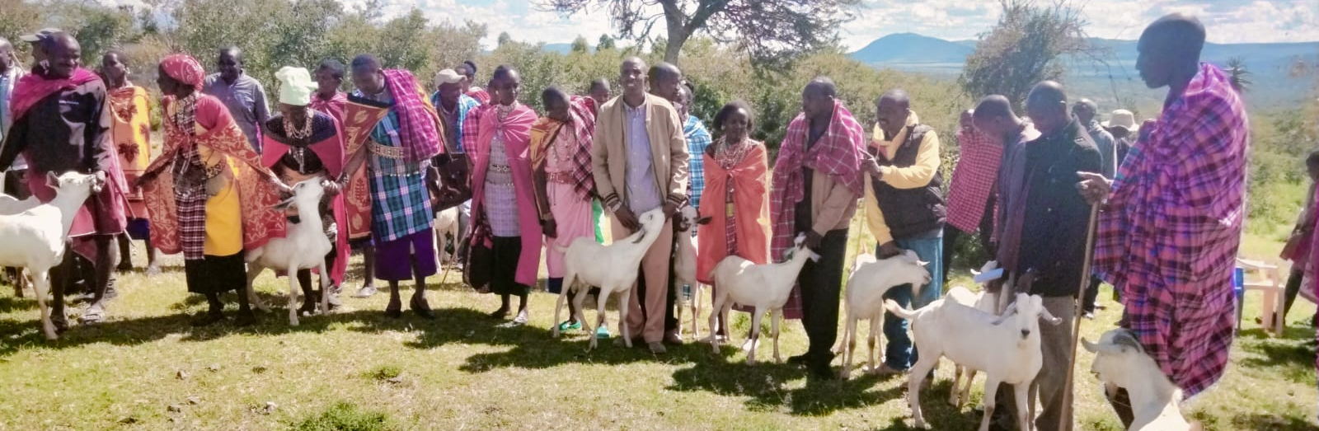
Galla bucks distribution
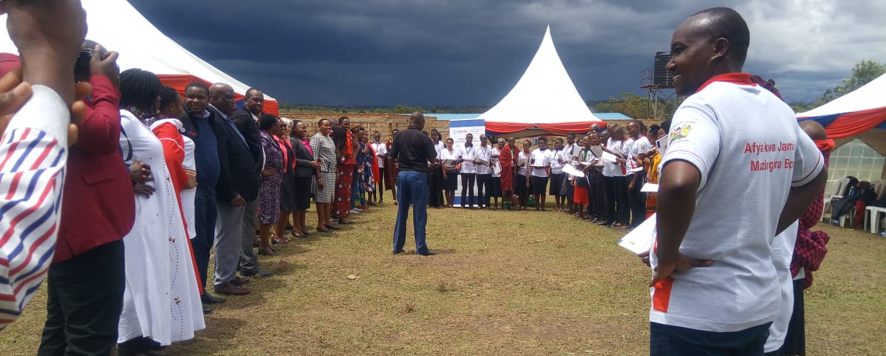
Graduating Community Based Distributers for Family Planning to increase uptake of FP services through NPI Expand Project
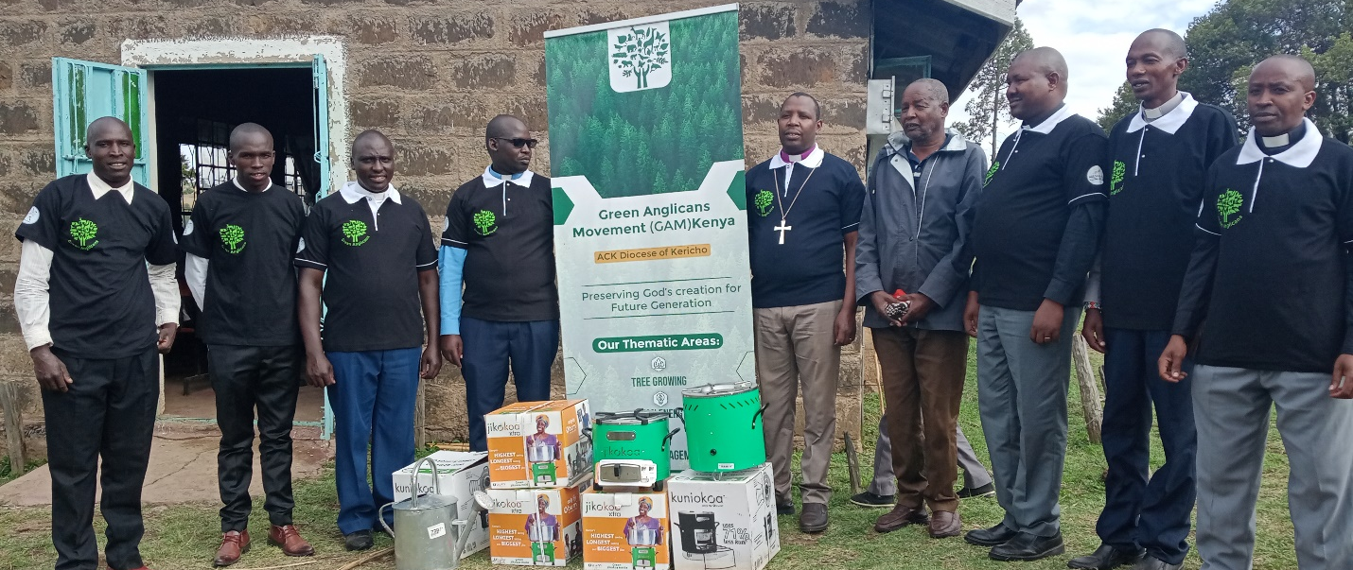
Launching the Green Anglican Movement Diocese of Kericho in Oct 2022 at Olkeri Parish.

Chapter 1

INTRODUCTION

- Introduction
Anglican Development Services (ADS) South Rift is the development arm of Anglican Church of Kenya Diocese of Kericho and is one of the 10 ADS Regions in Kenya. It operates in Bomet, Kericho and Narok counties with a population of 3 million people in an area of 21,900 square kilometers. The organization has been working with both rural and urban communities in these three counties.

The organization has been in operation since 1983 as ACK Narok Integrated Development Program (ACK NIDP) and ACK Trans- Mara Rural Development Program (ACK TRDP). To align with the expanded geographical coverage and scope, all the ACK programs in South Rift consolidated and registered in 2015 as ADS South Rift.

The organization has extensive experience in designing and implementing various projects through various community engagement processes such as Church and Community Mobilization process (CCMP), Participatory Evaluation Process (PEP), Participatory Vulnerability Capacity Assessments (PVCA), Citizens Voice and Action (CVA), Community Challenge and Community Based Adaptation (CBA) Approach. As a result, communities identify and prioritize their needs, opportunities and resources then take actions to address them integrating disaster risk reduction strategies.

We are a community- centered organization that is helping them bring out their potential. Since inception we have trained farmers to increase food production and be food secure, we have provided health care hence improving health status of the community, we have sponsored many children in schools, and we have reached out to over 10,000 OVC. We have helped communities improve their livestock breeds. The first strategic plan covering 2017 to 2020 helped refocus the organization, human resources development and built her capacity and structures to manage transformative programs within the communities we partner with.

1.1 Strategic Planning Process
ADS South-Rift leadership organized a three-day workshop to formulate the new Strategy. The process was preceded with a questionnaire that was sent to key stakeholders requesting them to provide information on areas that ADS South Rift should focus on. Board members, staff and key stakeholders were invited to join the workshop at the ACK Mara Empiris camp. The process was participatory. The participants were taken through theory and practice of strategic planning and reviewed the previous strategic plan. They also participated in an intensive scanning of the environment through PESTEL, SWOT and Stakeholders analysis. The team thereafter reviewed the vision, mission and core values. They further identified three pillars and strategic goals, objectives, results and activities. The activities were costed and a logical frame work for each pillar developed. The strategic plan process was also informed by the organization capacity assessment which provided new insights and gaps.

  - Strategic Planning Rationale
Strategic plan has become a structured way of managing organizations as part of strategic management. It comprises of three parts i.e. formulation, implementation and control (Monitoring and evaluation). Any serious organization must develop strategic plan. Strategic plans enable an organization to rally all stakeholders to a common goal and course; it is the basis of resources mobilization and allocation and help to measure an organization’s performance.

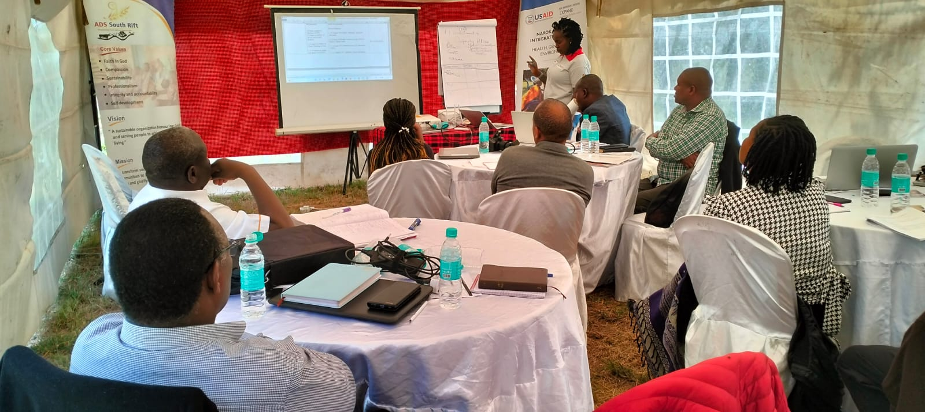
Team of staff engaging in developing the ADS South Rift Strategic plan 2023-2027

Chapter 2

REVIEW OF 2017-2020 STRATEGIC PLAN

2.1 Lessons from the previous strategic plan (2017- 2020)
The organization during the planning process was able to review the previous strategic plan. This sought to examine the extent to which the strategy was realised and also identify from the capacity assessments what gaps are. The findings were as below and summarized in the table 1:
- Resource mobilization was highlighted among the recurrent reasons why planned activities were not achieved.
- Pandemic-The Corona pandemic adversely affected the organization’s operations as well as communities. It was unprecedented and unexpected.
- Inadequate monitoring and evaluation
- Inadequate communication of the strategy to the people and stakeholders
- Inadequate capacity building for board and the staff.

The following strategic Issues were raised in the organizational capacity assessment carried out recently by our partner USAID Palladium group- NPI.
- Inadequate Resource Mobilization
- Weak Indicators and measurement
- Lack of regular Organizational capacity assessment
- Inadequate Corporate governance and training
- Wide region covered by the programs
- The need for a Board manual
- Inadequate Gender mix in the board
- Organizational Sustainability
- Parameters of tax exemption
- Successional planning
- Internal and external Communication plan
- Corporate branding
- Partnership documentation (Memorandum of Understanding)
- Integration of gender and disability
- Organizational risk management
- Strategic planning- cascading the document so that everybody owns a copy and is implementing
- Inadequate Business plan
- Strengthen Financial management- charts of account, dissemination of the financial document, procurement procedures,
- Banking- utilizing the updated systems and harmonizing them
- Improve Grants management
- Strengthen Internal controls
- Enhance Accountant’s capacity
- Integrate Information and Communication Technology (ICT) and have a policy
- Improve Human resource management and development- performance management/ appraisals, work force planning, staff retention and motivation, staff training and development
- Strengthen Monitoring and evaluation planning
- Formulate Gender integration Policy
- Introduce Advocacy programming

It was noted that these areas should be included in the new strategic plan for growth and effectiveness in operations of ADSSR.

The three groups formed in the workshop presented their findings on why the previous strategic plan did not achieve the desired targets as captured in the table below;

Table 1: Key Results of the Review of 2017- 2020 Strategic Plan
Pillar | Key Achievement | Unachieved Targets | Cause for non- achievement | Recommendation
Programmes | Human Health (Empower communities to be self-reliant)  - Immunization of children restored health status  - Increase in hospital deliveries improved access to quality health care.  - Post- natal care  - Iimproved health care  - Two staff houses in Nturumenti | - Establishment of a fully functional hospital at Nturumeti in Narok.  - Establishing a laboratory facility at Olendeem dispensary.  - Establish a dispensary in Kericho | - Inadequate resources | - Prioritize resource mobilization
Programmes | Livelihoods  - 62 savings & credit groups improved credit access with 500 households impacted with access to credit.  - Farming projects in Transmara improved food security  - Peace building enhanced peaceful co-existence, reduced deaths and loss of property  - The participatory methodology CCMP exceeded targets. Enabled communities to envision and transform their lives.  - 44 FFS groups of 36 households established and enhanced food security and nutrition status.  - 10 KCDT groups were established in CDCs in Transmara. The accessed credit to communities hence improved livelihood.  - Enhancement of dairy farming in Manaret and Narok and centralization of milk sale business in both places. The community income and standards improved.  - Livelihood  - Establishment of 30 FFS households established and enhanced food security and nutrition status.  - Establishment of farming projects in Transmara and Saruchat. | - Two irrigation schemes in Olkeri  - Climate change- tree nurseries |  | -Fundraise and establish the two irrigation schemes  - Establish tree nurseries  - Introduction of Income generating activities at household level  - Training on Income generating activities (IGAs)
 | Health HIV & AIDS  - Immunization of 13,910 under 5years improved health status  - Establishment of a functional dispensary in Nturumenti access to quality health care  - Construction of 1 staff house in Nturumenti enabled access to health worker | - Establish a dispensary at Punsaki in Transmara West | - Inadequate resources | - Resource mobilization through proposal writing
 | Peace building  - Conducting peace building forums among communities enhanced co-existence  - Support and facilitated advocacy initiatives to resolve conflict enhanced community ability to resolve conflict | - Facilitate staff and clergy capacity building to enhance ability to resolve conflict. |  | - Capacity building of clergy and staff.
 | - OVC Care & Support  - Over 2600 OVCs enrolled into programs within the Church. Restored human dignity  - Focus on achievement of 100% holistic development.  - OVC Care & Support  - Enrolled more than 3000 OVC to access services hence improved protection and standards of living  - Increased referral linkages restored children dignity  - Link needy children in Church in OVC programs restored children dignity | - Not all OVCs within a household are supported. | - Inadequate resources | - Development/ creation of IGAs within the Churches.
Human Resource | - Enrollment of staff to SACCO- KCDT staff access credit for personal development  - Appraisals done helped improve staff performance  - Job descriptions/ profiles donefor clarity of all jobs  - Annual salary reviews  - Enhancing staff welfare by establishing a SACCO for easy access to credit to foster personal development.  - Enhance team cohesion improved organization performance | - Staff motivation awards  - Adequate capacity building  - Implement motivation strategies e.g. staff of the year, staff of the month etc. |  | - Allocate resources for staff capacity building and motivation initiatives.
 | - Formulation of job profile  - Establishment of budget lines for staff training  - Team building activities | - Establishment of SACCO (KCDT)  - Staff appraisal | - Motivation Strategies for staff (staff of the year) | Undertake Job Analysis and Evaluation.  Under take needs assessment and training.
Institutional Development | - Governance- board is in place enhance oversight.  - Policies and procedure manuals developed  - Finance manager hired  - Annual external audits done  - Formulation of ADS South Rift policies website and organizational structure.  - Website update  - Rebranding  - Formulation of policies | - ICT Integration  - Website not updated  - Effective M&E by the Board  - Resource planning not done  - Board retreat not done  - Inventory of assets not done  - Consolidation of assets and inventory monitoring system. This is at program level.  - Maintain property coded charts of accounts.  - Formulation of some policies | - Lack of a centralized purchase system.  - We use different systems of accounting systems that is QuickBooks and Safina.  - Lack of expertise | - Procurement should be done from a centralized point that is the headquarters.  - Contract a consultant for support to develop policies.
Property & Investment | - Construction of a tented camp in Maasai Mara road to raise local funds  - Purchase of land for future investment | - Resource mobilization officer  - Utilization of idle land in conjunction with the diocese  - Narok Hotel Phase 2  - Asset Register  - Rental Houses in Transmara  - ADSSR properties that is hotels and restaurants does not put into account disability needs e.g. elevators, toilets and rumps.  - Construction of rental houses in Transmara | - Inadequate resources | - Resource mobilization  - Enhance sustainability especially on enabler projects at the Archdeaconry level
 |  |  |  | - Prioritization of the unachieved activities in the next planning phase
 | - Construction of a tented camp in Maasai Mara | - Construction of Narok Hotel & conference facility phase 2  - Construction of rental houses in Transmara | - Inadequate resources  - Covid 19 pandemic | - Resource mobilization

Chapter 3

SITUATIONAL ANAYISIS

  - Situation analysis
Organizations operate in a very competitive environment. The world is emerging from adverse effects of Corona pandemic on world economy which led to deaths, shutdown and loss of jobs. Still, at the global level the operating environment is witnessing conflict in many countries with the war in Ukraine having led to the increase in oil, gas and food prices worldwide. In addition, the effect of global warming and climate change has led to unreliable rainfall and high temperatures. The world through UN has developed sustainable development goals (SDG) which target countries and organizations are implementing.

In Africa, particularly the East and Horn of Africa, the devastating effects of climate change in particular the persistent drought has brought a lot of suffering to communities with loss of animals and livelihood which includes areas where ADSS implements her programmes.

In Kenya, the country is slowly emerging from contentious election and mass demonstrations, struggling economy, drought (with at least four seasons of rain failure), a health system that does not have sufficient medicine and other supplies and staff shortage, high cost of living and ever-increasing price of oil, a very high level of youth unemployment and increased poverty levels. The cost of education with the newly introduced education system also poses challenge to parents and communities. The devolved government structure in her ten -year implementation provides lessons that affect the PESTLE analysis. The Kenyan currency is equally performing poorly. ADS SRoperates in a conflict prone area with regular tribal and clan clashes. The situation analysis below considers all the context above and are aligned through the PESTLE, SWOT and Stakeholder Analysis.

  - PESTLE (Political, Economic, Social Technological, Ecological)

Table 2: PESTLE ANALSIS RESULTS:
Factor | Effect |  | Response
 | Positive | Negative
Political | - Goodwill necessary for donor support  - Compliment what the Church and Government is doing  - Tap government’s resources  - Leadership mindset  - Willingness to serve the community | - Loss of life and property  - Inaccessibility to offer services  - Interference with activity implementation  - Political favoritism on placement of projects and staffing  - Sabotage of the development process  - Corruption  - Inhibit development and production. | - Involvement and sensitization of community and especially the youth  - Feedback reports  - Community empowerment on public participation and their rights.
Economic | - Subsidized agricultural products  - Cheap labor  - Support livelihoods | - High cost of living  - Inflation  - Unemployment  - Low income  - Inflation affects budget implementation  - Negative impact of Covid 19 pandemic  - High cost of doing business.  - Corruption  - Global economic crisis affects service delivery  - Unemployment | - Livelihood support programmers (goats, beans, FSS, KCDT)  - Advocacy  - Build resilience through diversification  - Flexibility in investment
Social | - Communities are receptive to new projects.  - There are laid down structures within the communities.  - Strong family ties in some families  - Utilize strong ties in the community  Pandemic | - Retrogressive cultural beliefs and practices like FGM  - Male dominance in families and community decisions.  - Low literacy levels.  - Teenage pregnancy  - Negative ethnicity  - Poor infrastructure e.g. roads, health facilities, social amenities, schools.  - High illiteracy levels.  - Moral degradation (LGBTQ )  - Adolescent contraceptive intake  - Inter-generational differences.  - Increase in crime.  - Use of technology in the right way.  - Innovations  - Improved hygiene | - Community sensitization forums.  - Equitable distribution of resources and projects.  - Enhance continuous peace initiatives  - Engage opinion shapers in the community to speak positive about importance of cohesion.  - Male involvement in development work.  - Women involvement in decision making.  - Community needs assessment and mobilization strategies  - Intervene where there is community conflict.  - Design age- specific interventions  - Clear policies  - Youth- friendly services  - Shutdowns/ lockdowns  - Loss of humanity (deaths)  - Loss of social fabric  - Affected resource base  - Job turnover and loss  - Change of lifestyle such as restriction of movement, social distancing  - Effect on the school calendar activities.
Technological | - Enhanced internal and external communication  - Online meetings  - Online banking  - Digital programming e.g. M & E systems, HR systems  - Coverage and dissemination of information is quick.  - Helps in marketing and branding.  - Availability of local radio and TV stations  - Virtual meetings  - Increase of access to information | - Uncontrolled social media content  - Hacking  - Negative reporting/ communication  - Information overload  - No measures to curb cyber crime  - Loss of jobs | - Teaching people new skills  - Reduction of costs in conducting meetings.  - Adopt digitalization platform  - Data protection measures and policies
Legislation | - Promotes law and order. | - Finance Act (taxation) can be burdensome in communities.  - Poor enforcement of laws e.g. anti FGM Children Act  - Laws governing registration of organizations  - Some legislations are against the faith i.e. Pro LGBTQI+ laws  - Some legislations limit funding opportunities.  - New business legislations e.g. permits | - Advocacy engagements and stakeholders.  - Dissemination of the laws enacted.  - Enhance compliance
Ecological | - Reception of training and activities to address climate change.  - Create business opportunity with good planning. | - Climate change food security, drought  - Unpredictable weather patterns affect program implementation.  - Crop failure  - Pests and diseases  - Human wildlife conflicts affect production of food. | - Promote GAM activities  - Establishment of free nurseries and tree growing  - Sensitization of community on diversification of agricultural activities.  - Diversification of livelihoods  - Environmental conservation (soil, water)  - Research on drought resistant crops

  - SWOT Analysis

Table 3: SWOT ANAYSIS RESULTS
SWOT ANALYSIS
Strengths  - Experience working in communities  - Good relationship with the national and county Governments of Kenya and partners  - Being a faith- based organization trusted with resources  - Good name and working relations with stakeholders.  - Long experience in implementation of social-economic transformation programmes  - Qualified, professional and competent staff  - Well understood vision and mission as a church  - Community goodwill and local presence  - A wide coverage working nationally as part of ADS family | Weaknesses  - Inadequate ADSSR structures and implementation  - Insufficient resource mobilization strategy  - Inadequate internal and external communication system  - Limited financial resources to respond to many community needs  - Inadequate staffing in key areas e.g. M and E, Communication and ICT  - Donor reliant for most of our projects  - Inadequate monitoring, evaluation, reporting and communication system.  - Digital communication access/ platforms
Opportunities  - Large mission field and untapped coverage areas  - Devolved county governments - Kericho, Bomet, Narok  - Strong partnership with external partners  - External support from the National and County Governments of Kenya- MOH, Department of Childrens Services (DCS), KALRO  - A good renown brand- ADS  - Use of technology  - Networking and collaboration with like-minded organizations  - We have a wide asset base in terms of land, labour and capital.  - Well placed to tap into the environment and climate change opportunities e.g. in Maasai Mara ecosystem, Mau Forest etc.  - Maximizing the opportunities presented by partners such as staff capacity building  - Harness the advantage of the numbers in our congregations | Threats  - Pandemic  - Climate change i.e. prolonged droughts/floods  - Negative ethnicity i.e. preference of staff from a particular ethnicity  - Declining donor funding  - Political instability and tribal clashes  - Retrogressive/ harmful cultural practices e.g. FGM, early marriages  - Population growth  - Economic instability

  - Stakeholder Analysis
Table 4: STAKEHOLDER ANAYSIS
Stakeholder | Level of Influence
 | High | Medium | Low
Church | #
Government (National & County) | #
Community- based beneficiaries | #
Development Partners/ Donors | #
Other NGOs and Civil Society Organizations |  | #
Community Opinion Shapers/leaders/volunteers |  | #
Faith leaders | #
Financial Institutions and suppliers |  | #
Staff | #
Board | #
Political Class |  | #
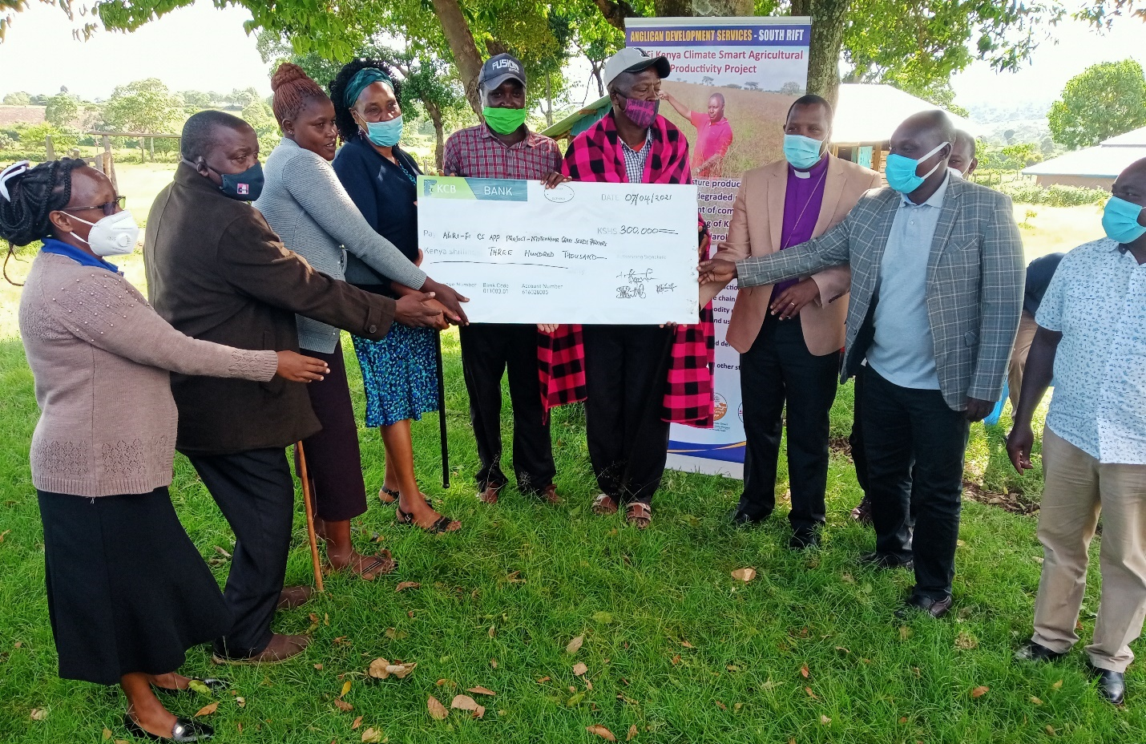
Farmers earning huge income from the grass value chain through KALRO AGRI-Fi CS APP grass project in Narok County

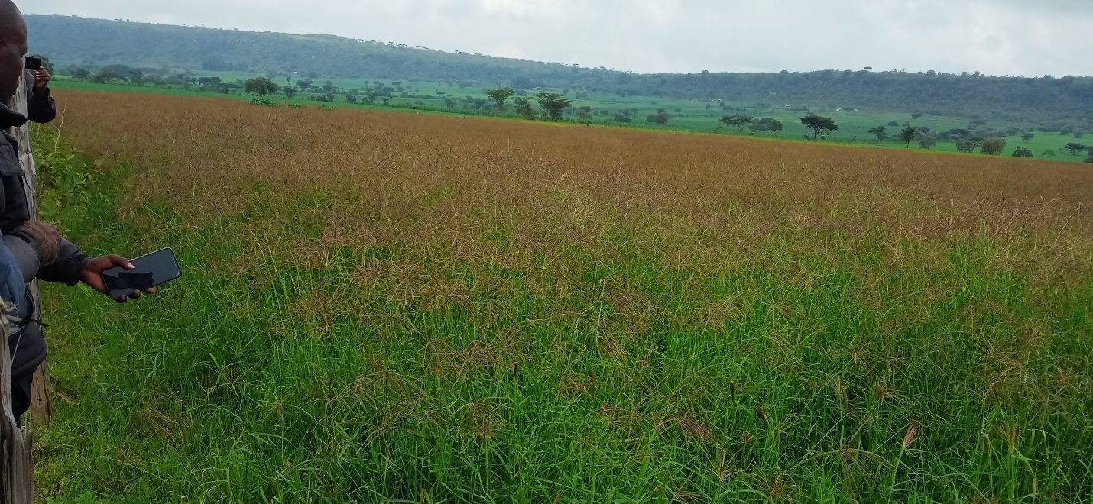
Supporting climate smart agriculture and restoring degraded range lands through grass planting and commercialization

Chapter 4

STRATEGIC ISSUES FROM 2017-2020 STRATEGIC PLAN

4.0 Strategic Issues
Strategic issues raised from the previous strategic plan, PESTLE and SWOT analysis are;
- Resources limitation and declining donor funding
- Political instability and tribal clashes
- Culture mood and organizational change
- Human and organization competencies
- Cost of living and weak economy
- Climate change
- Retrogressive cultural practices
- Inadequate Documentation and communication

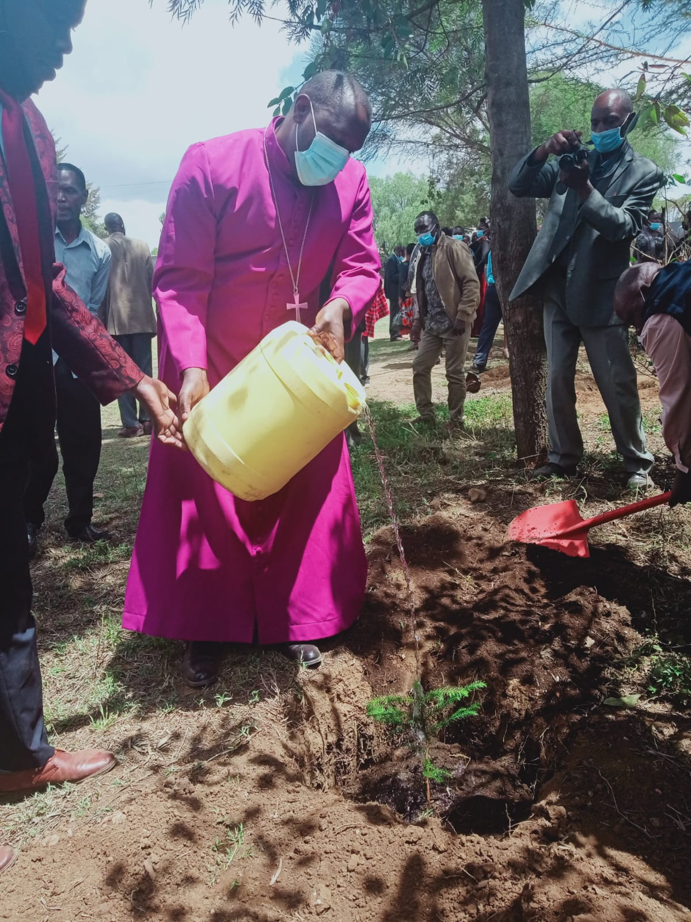
The Rt. Rev Ernest Ngeno leads in Green Anglican Movement activities in the region.

Chapter 5

NEW STRATEGIC DIRECTION

  - Vision
An organization honoring God and serving people to achieve a dignified living.

  - Mission
To transform society by empowering communities to holistically address their needs and glorify God.

  - Core Values
- Faith in God
- Growth, learning and innovation
- Stewardship
- Equity
- Teamwork
- Compassion
- Sustainability
- Professionalism
- Organizational and self- development

  - Conceptual Framework

Table 5: ADS South Rift Conceptual Framework
MANDATE
To proclaim the Good News of Christ through social ministry of the Anglican Church of Kenya

VISION
An organization honouring God and serving people to achieve a dignified living
Goal 3
To create a self- sustaining organization by enhancing income generating activity initiatives.

Goal 1
To empower communities in South Rift Region to be Self–reliant and self-sustained by 2027

Goal 2
To establish & strengthen systems, structures and policies to effectively deliver the organization mission

Strategies/Activities/input
Pillar 3
Property and Investment

Pillar 2
Organisation Sustainability and Transformation
Pillar 1
Community Development

Outcome 1 - Improved living standard for communities in the South Rift Region
Outcome 2 – Functional and reliable organization and systems
Outcome 3 – Available resources to meet the vision and mission of the organisation
MISSION
To transform society by empowering communities to holistically address their needs and glorify God.
  - Pillars
The following strategic Goals, objectives results and activities were identified under each of the three pillars of Community Development, Institutional Transformation and Sustainability and Property and Investment:

PILLAR 1: Community Development

Goal: Empower communities in South Rift Region to be Self–reliant and self-sustained by 2027

Expected Outcome: Improved living standards for communities in South Rift region

Thematic Areas under this pillar
- Human Health
- Livelihood and Economic Empowerment, Food security
- Climate Change
- Peace Building with strong focus on church community mobilization process (CCMP)
- OVC Care and Support
- Participatory Monitoring, Evaluation and Learning
- Emergency Response
- Gender and Disability Mainstreaming

Table 6: Community Development Pillar 1: Summary of Strategic Objectives, Results and Strategic Initiatives
Strategic Objective | Strategic Results | Strategic Initiative (Activities) | Estimated Cost (Kshs)
1.0 Human Health (HIV/MCH/FP)  To increase access to quality healthcare in South Rift region by December 2027 | 1.1 9000 Women and 7000 men reached with information on Family Planning and SRH  1.1 Families can make better informed FP choices  1.2 Materials on SBCC developed  1.3 120 youth trained as peer educators  1.4 90 Faith leaders trained on faith for life model to create awareness of FP and SRH  1.6 450 Youths sensitized on Adolescent Sexual and Reproductive Health/life skills.  1.7 5000 parents and guardians on Family health and parenting  1.8 Fully immunized children (10,000)  1.9 Improved quality of service at the health facilities  1.10 Improved uptake on Family Planning services  1.12 30 Improved quality and uptake of MCH/FP services  1.13 Strengthened clinical skills on LARC/PFPP through mentorships  1.14 Increased Budget allocation for FP services at the County level  1.17 Increased number of skilled deliveries  1.18 Increased number mothers accessing Post Natal Care services  1.22 Improved quality of data (valid, accurate, consistent, reliable) that can be used for decision making  1.23 Improved service delivery by the trained health care workers  1.25 Improved commodity forecasting, quantification, accountability and management.  1.26 Reduced levels of stock outs  1.29 Reduced defaulter rates  1.30 Improved quality of service for the PLHIVs  1.36 Improved quality of data for decision making  1.39 Strengthened stakeholder relationship networks  1.1.42 16,000 people reached with nutrition messages to promote healthy eating and good dietary practices  1.1.43 90 schools supported with Nutrition education sessions to promote healthy eating and good dietary practices | (i) MCH/FP  Demand Creation  A1.1.1 Support quarterly community sensitization forums through existing Women, male and youth forums on FP information to dispel myths and misconceptions  A1.1.2 Develop social behavior change and communication materials (SBCC) on FP  A1.1.3 Conduct 3 days training for 120 youth peer educators on SRH and FP to create awareness on FP and SRH  A1.1.4 Train 90 faith leaders through the faith for life model to create awareness on MH& FP  A1.1.5 Engage 90 faith leaders to create awareness on MH& FP  A1.1.6 Conduct three days sensitization for 450 youths on Adolescent Sexual and Reproductive Health/ life skills.  A1.1.7 Engage 5000 parents and guardians on Family health and parenting  (ii)Service Delivery  A1.1.8 Support 30 monthly community integrated outreaches  A1.1.9 Train 300 Health workers on LARC/PPFP to improve clinical skills  A1.1.10 Train 120 Community-based FP Distributed (CBDs)  A1.1.11 Support 120 Community Based Distributors through monthly stipend  A1.1.12 Conduct 30 quarterly support supervisions & mentorship for quality improvement  A1.1.13 Conduct 4 mentorship activities on LARC/PFPP to strengthen clinical skills  A1.1.14 Conduct 10 advocacy meetings with county leadership for improved FP service delivery and resourcing  A1.1.15 Support County/ Sub County Health Management Teams to Participant in development of CIDP and AWP  A1.1.16 Fully immunize 10,000 children under 5 years  A1.1.17 Increase hospital deliveries by 3,000 mothers  A1.1.18 Provide post-natal care and Family Planning to 6,000 mothers  A1.1.19 Reach out to 11,000 men with reproductive health messages/ services  A1.1.20 Reach out to 20,000 youth and children in and out of school with health messages and services.  A1.1.21 Establish a dispensary in Kericho Archdeaconry  (iii) Health Information Management  A1.1.22 Conduct quarterly RDQAs for data validation to ensure consistency and accuracy of reported data  A1.1.23 Conduct three days training for 300 health workers on data management to enhance FP data quality  A1.1.24 Conduct research to support evidence-based advocacy and programming in FP and SRH  - Commodity Security  A1.1.25 Support 10 mentorship sessions for health workers along the FP Commodity supply chain to improve commodity forecasting, quantification, accountability and management.  A1.1.26 Support 3 County Commodity Security TWG to provide mentorship and oversight  A1.1.27 Conduct 10 advocacy meetings with county leadership for improved FP service delivery and resource mobilization  A1.1.28 Conduct 4 Multi-sectorial meeting with county government, relevant sectors and CSOs to strengthen integration and funding for FP.  (iv) HIV AND AIDS  A1.1.29 Conduct training of new 100 CHVs to provide adherence counselling, defaulter tracing or treatment literacy to PLHIV (Train New CHVs on HCBC)  A1.1.30 Engage new and old CHVs to provide adherence counselling, defaulter tracing or treatment literacy to PLHIV  A1.1.31 Conduct Home visits to PLHIVs by CHVs  A1.1.32 Support groups to enhance disclosure, psychosocial support, adherence and defaulter tracing in the community  A1.1.33 Hold Quarterly facility Review Meetings to enhance community linkage and data review  A1.1.34 Hold monthly data collection fora with CHVs  A1.1.35 Hold Quarterly Review and coordination Meetings with CHVs  A1.1.36 Support Quarterly Data review meetings with CHEWs per Subcounty  A1.1.37 Support Data review for community units and linked facilities, conducted by the SCHMT  A1.1.38 Conduct M&E visits to TCS sites (PLHIV homes, facilities, etc.)  A1.1.39 Participate in stakeholders meetings (County/sub county stakeholders meetings, HIV TWGS etc.)  Nutrition  A1.1.40 Participate in Malezi Bora event  A1.1.41 Support Quarterly County Nutrition Technical Working Group meetings to effectively coordinate delivery of improved nutrition interventions  A1.1.42 Conduct Quarterly Community Nutrition sensitization on diet diversification and appropriate MIYCN for improved feeding practices  A1.1.43 Conduct Nutrition education session in 90 schools to promote healthy eating and good dietary practices | 33,623,010.00  65,482,000.00  12,060,000.00  4,345,000.00  100,000,000
1.2 Livelihoods and Economic Empowerment  To economically empower 6,000 households to provide for themselves and others in South Rift region by December 2027 | 1.2.2 Improved Livelihoods for 8600 households  1.2.3 Financially stable families  1.2.4 Sustainable food security | A1.2.1 Establish 30 farmers Field school (F.F.S) groups of 36 households each.  A1.2.2 Establish 120 economic empowerment groups of 3,600 households through Kericho Community Development Trust (KCDT)  A1.2.3 Empower 5000 households by establishing 250 groups of 20 members each through the ADS SR site offices.  1.2.4 Enhance dairy farming in Manaret and Narok and centralized milk sale business in both places  A1.2.5 Establish 2 irrigation schemes at Olkeri parish and Erupata  A1.2.6 Enhance food security among 5000 households in Bomet County through climate smart Agriculture-Beans Value chain | 1.2.2.1 @50000 per group for 30 FFs groups=1.5M  1.2.2.2@30,000 per group for 120 groups=3.6M  1.2.2.3@20,000 per group for 250 groups=5M  1.2.2.4 @5000 (AI & Facilitator) -500 farmers with 2 cows each=1000  1000*5000=5M  1,000,000
1.3 Climate Change  Increase community resilience to effects of climate change on livelihoods in 10,000 households in South Rift by 2027 | 1.3.1 500 ToTs trained on environmental stewardships  1.3.5 30 clergy and 40 staff and community members trained on disaster preparedness, Disaster Risk Reduction and response  1.3.9 10 Boreholes Drilled to enhance access to clean safe water for human and animal consumptions and promote irrigation activities | A1.3.1. Build capacity of 500 of ToTS through training on environmental stewardship  A1.3.2 Facilitate 240 community awareness forums on climate change adaptation.  A1.3.3 Formulate and adopt policies on climate change adaptation by observing environmental weeks and tree planting during Diocesan events.  A1.3.4 Establish community tree nurseries in 4 Archdeaconry  A1.3.5 Train 30 clergy,60 staff and community members on disaster preparedness, Disaster Risk Reduction and response  A1.3.6 Be a member of the likeminded environmental movements  A1.3.7 Develop policy on tree planting in 10 per cent of church land and lands owned by church- sponsored institutions.  A1.3.8 Incorporate 200 schools within the South Rift Region on environmental conservation interventions.  A1.3.9 Drill 10 Boreholes  A1.3.10 Establish water harvesting technics (10 water pans, 500 tanks) | 1,000,000  1,500,000  1,500,000  4,000,000  2,500,000  100,000  No Cost  5,000,000  1,000,000  35,000,000  15,000,000
1.4 Peace Building  To enhance peaceful coexistence between communities in South Rift region by 2027 | 1.4.1 Peace stability  1.4.2 Peaceful coexistence among communities  1.4.3 Intermarriages among the communities  1.4.4 Business collaborations among the communities | A1.4.1 conduct 20 peace building forums among communities living South Rift region  A1.4.2 Organize Annual ADSSR Marathon and 10 football/Volley ball matches to enhance peaceful coexistence among communities  A1.4.3 support and facilitate 4 advocacy initiative to resolve conflicts  A1.4.4 Facilitate staff and clergy capacity building to enhance ability to resolve conflicts  A1.4.5 Foster and strengthen partnership with expert organizations in peace building and conflict resolution. | 1,000,000  1,200,000  2,000,000  2,500,000  500,000
1.5 Advocacy  To create awareness for the community members to understand their rights and raise voice to influence decision making processes at local and County levels | 1.5.1 Communities participation in decision making processes  1.5.3 Reduced cases of GBV, Child marriages, FGM  1.5.4 Strengthened partner relationships | A1.5.1 Train and build the capacities of individuals and communities to meaningfully participate in decision making forums  A1.5.2 Support 250 quarterly community awareness creation forums  A1.5.3 Disseminate laws and regulations against Gender Based and Domestic Violence, Child protection laws.  A1.5.4 Identify and work with likeminded partners to carry out advocacy interventions  A1.5.5 Lobby local Government authorities to pass laws that protect the vulnerable  A1.5.6 Participate jointly as ADSSS Region in marking of Key International/ World/National Days | 5,000,000  6,000,000  6,000,000  2,500,000  1,000,000  6,000,000
1.7 OVC Care and Support  To improve the living standards of 7,000 orphans and vulnerable children in South Rift by 2027 | 1.7.1 improved livelihoods for 7000 OVC  1.7.3 Strengthened referral and linkage platform | A1.7.1 Enroll 2,200 new OVC (7000-4,800) to OVC program  A1.7.2 Support OVC core services for 7,000 OVCs by offering education, food and nutrition, shelter, economic empowerment, psychosocial support, protection, and health care services.  A1.7.3 Support referral and linkages for services  A1.7.4 Engage the Church to support OVC work  A1.7.5Link the needy children in church with OVC programs. | 30,000,000  50,000,000  2,000,000  100,000  200,000
1.8 Participatory Monitoring, Evaluation and Learning | 1.8.1 Baseline and End line survey reports  1.8.2 Quality reports that are reliable, accurate, valid, consistent  1.8.3 Timely submission of reports  1.8.4 Quality service delivery | A1.8.1 Conduct baseline study and End line survey for all projects  A1.8.2 Conduct quarterly RDQAs to validate the accuracy, reliability, completeness, consistency and availability of reports/ data submitted  A1.8.3 Conduct Monthly review meetings to monitor project progress and address emerging challenges during implementation  A1.8.4 Conduct quarterly review meetings at Subcounty/County level  A1.8.5 Support Monthly data Collection of program reports  A1.8.6 Conduct quarterly Support supervisions & mentorship for quality improvement  A1.8.7 Conduct quarterly M&E visits to assess programmes progress  A1.8.8 Conduct monthly staff and planning meetings  A1.8.9 Documentation of success stories and best practices  A1.8.10 Develop tools for Data Collection  A1.8.11 Reporting | 10,000,000
1.9 Emergency Response  To promote preparedness for communities to cope with emergencies such natural disaster and pandemics in South Rift Region by 2027 | 1.9.1 30 clergy and 40 staff trained on disaster preparedness  1.9.2 Community aware on disaster preparedness measures  1.9.3 Resilient communities in case of emergencies | A1.9.1 Train TOTs (30 Clergy and 40 staff) on disaster preparedness  A1.9.2 Conduct 100 community sensitization forums on disaster preparedness  A1.9.3 Avail safety equipment to all ADS facilities such as lightning arresters | 5,000,000
1.10 Gender and Disability Mainstreaming  To promote Gender equality and disability inclusion in South Rift Region by 2027 | 1.10.7 People with disability will attain their full potential in life.  1.10.3 Improved living standards for persons with disability  1.10.5 Better treatment for PWDS  1.10.4 Equal access to opportunities and resources  1.10.2 Trained staff and clergy on Gender mainstreaming | A1.10.1 Disseminate policies and laws that promote gender equality.  A1.10.2 Capacity building of staff, and clergy on gender and disability mainstreaming  A1.10.3 Sensitization of community members to reduce stereotypes and increase participation and representation in decision making fora.  A1.10.4 Partner with the Department of Health and National Council for Persons with Disability (NCPWD) for registration and placement of Persons with Disability.  A1.10.5 Facilitate advocacy trainings to reduce stereotypes, increase participation and representation.  A1.10.6 Training of teachers and all staff of the ACK schools on disability and inclusion  A1.10.7 Advocate for inclusion of special facilities in schools, Hotels, Churches to make them disability- friendly.  A1.10.8Link and refer persons with disability for assistive devices including visual impairment guides, brails, wheel chairs, clutches  A1.10.9 Advocate for a sign language interpreter in churches.  A1.10.10 Support Gender Sector Technical working group meetings | 20,000,000
Total Estimated Budget 412,660,010.00

Table 7: Pillar 2: Organization Transformation and Sustainability
Pillar 2: Organization Transformation & Sustainability
Goal: Establish & strengthen systems, structures and policies to effectively deliver the organization Vision and Mission
Outcome: Functional and reliable systems and processes.
Focus area | Strategic Objective | Strategic result/Outcome | Activities | Cost
Governance | 2.1 Strengthened ADSSR board and program committee to comply and provide oversight | An effective and well Governed organization | 1. Restructure the board to reflect Gender, disability and professional skills and expertise | 100,000
Governance |  | An effective and well Governed organization | 2. Train ADSSSR Board & Program committee to effectively perform their oversight roles | 500,000
Governance |  | An effective and well Governed organization | 3. Support Board & program committees to conduct at least four meeting | 1,000,000
Governance |  | An effective and well Governed organization | 4. Establish and review existing policies and manuals to ensure statutory compliance and best practices (Safeguarding, risk, whistle blowing, health and safety, complain and feedback mechanism and code of conduct, data protection plan among others etc.) | 500,000
Governance |  | An effective and well Governed organization | 5. Establish an organization policy inventory | 100,000
Governance |  | An effective and well Governed organization | 6. Establish OCA implementation and review framework | 0
HR Management & Development | 2.2 Recruit, Motivate and retain a result -oriented workforce | Enhance Organization performances and efficiency | 1. Recruit adequate staff to ensure proper segregation of duties at ADS Secretariat & Program level
HR Management & Development |  | Enhance Organization performances and efficiency | 2. Support continuous staff training and development | 1,000,000
HR Management & Development |  | Enhance Organization performances and efficiency | 3. Develop a proper appraisal and succession manual | 200,000
HR Management & Development |  | Enhance Organization performances and efficiency | 4. Establish a staff motivation plan. (support staffs motivation through salary increment, promotions, team building and annual staff of the year recognition) | 2,000,000
Financial Management | 2.3 Enhance Resource mobilization and optimization to achieve organization mandate | Self-sustaining organization with a diversified resource base | 1. Develop a resource mobilization strategy | 100,000
Financial Management |  |  | 2. Establish a resource mobilization desk/team | 6,000,000
Financial Management |  |  | 4. Develop a centralized accounting financial system with adequate backup. | 500,000
Financial Management |  |  | 5.Develop centralized coded chart of accounts for ease of consolidation | 300,000
Financial Management |  |  | 6. Continuously assess the existing internal control to minimize risk | 300,000
Financial Management |  |  | 7. Maintained a consolidated tagged asset register | 0
Financial Management |  |  | 8. Automate financial services | 750,000
Financial Management |  |  | 9. Conduct project and institutional audit & develop audit action list | 400,000
Financial Management |  |  | 10. Hire an IT/ Communication Staff to maintained the network system; allocate system access rights and organization Website | 6,000,000
Procurement Management |  |  | 1. Establish a procurement policy | 300,000
Procurement Management |  |  | 2. Establishment of functional tendering committees | 250,000
Organization Structure | 2.4 Well documented and communicated organizational structure | Improve coordination and reduce duty overlaps | 1. Undertake Organization structure review to define Communication and reporting protocols | 100,000
Participatory Monitoring, Evaluation and Learning | 2.5 Well managed project with structures to ensure proper planning and implementation of program activities. | A robust M&E system clearly defining expected outputs, deliverables, and indicators of success. | 1. Develop an M&E system to adequately track project implementation. | 1,500,000
Participatory Monitoring, Evaluation and Learning |  |  | 2. Set -up a functional Monitoring and Evaluation Monitoring and Learning team | 6,000,000
Participatory Monitoring, Evaluation and Learning |  |  | 3. Develop a Monitoring and Evaluation Monitoring and Learning plan (MEL) | 200,000
Participatory Monitoring, Evaluation and Learning |  |  | 4. Develop an M&E policy and implementation plan. | 300,000
Risk Management | 2.6 Safeguard stakeholders interest | To mitigate risk and minimize fraud that could threatened the realization of the organization set objective | 1. Develop a risk management policy | 100,000
Risk Management | 2.6 Safeguard stakeholders interest |  | 2. Establish and continuously assess statutory, safety and workmanship organization compliance | 200,000
Risk Management | 2.6 Safeguard stakeholders interest |  | 3. Sensitize staff on risk mitigation areas | 200,000
Risk Management | 2.6 Safeguard stakeholders interest |  | 4. Insure all organization properties and assents against risk (fire, theft, political & violence) | 10,000,000
Risk Management | KES 30,200,384.20

Table 8: Pillar 3 Property and Investment
Pillar 3: Property and Investment
Goals: Create a self- sustaining organization by enhancing income generating activities and initiatives.
Expected Outcomes: Avail resources to meet vision and mission of the organization
Strategic Objectives | Strategic Results | Activities | Estimated cost
Business Development  3.1 To increase ADS SR unrestricted funds by 30% by 2027. | 3.1.1. Professionally managed business entities | A3.1.1 Develop a centralized business management plan for the ADS SR businesses including Guest houses, rental houses/offices, dispensaries | 120,000
 | 3.1.2 Completed and functional phase 2 of Narok guest house  A3.1.3 Buy land and construct 5 rental units in Transmara  3.1.3 5 rental units completed and functional | A3.1.2 Construct Narok Guest house conference facility phase 2 (1st floor and restaurant | 5,000,000  6,000,000
 | 3.1.4 2 facilities professionally managed, sustaining themselves and making profits | A3.1.4 Commercialize 2 health facilities in Nturumeti, Olendeem to be self-sustaining | 3,000,000
 | 3.1.5 Pasture farms established and earning income from the sales | A3.1.5 Establish 50 acres pasture farm project in Transmara and Narok and a dairy farm in Sotik | 1,000,000
 | 3.1.6 Goat farm established and earning income | A3.1.6 Establish a goats farming project in Mara with 100 goats | 1,000,000
 | 3.1.7 Mara camp expanded and well equipped, attracting more customers | A3.1.7 Increase the number of tents from 15 to 30 and equip the facility, construct 1 conference hall, 1vehicle, swimming pool and a chapel | 20,000,000
 | 3.1.8 Property and investment policy developed and in use | A3.1.8 Develop and implement property and investment policy | 100,000
Asset Management  3.2 To improve organizational asset management | 3.2 An asset management policy developed and in use | A3.2 Develop an asset management policy | 50,000
Risk Management  3.3 To increase awareness and mitigation of potential risks | 3.3 A risk management policy developed and in use | A3.3 Develop a risk management policy | 50,000
Compliance:  3.4 To comply to all government requirements in running the ADS SR businesses | 3.4.1 Organization complying in all areas | A3.4.1 Register, subscribe and comply with all the required bodies and legal requirements- Public Health, VAT, PAYEE, Housing, NCA, Disability, labour laws, Occupational safety. | 50,000
 | 3.4.2 Staff capacity on compliance increased and staff complying | A3.4.2 Train staff on compliance | 300,000
Resource Mobilization  3.5 To increase the organizational funding base to meet the strategic plan budget | A resource mobilization team identified, documented | Document and strengthen resource mobilization team | 100,000
 | A fundraising portal created and in use | Set up and utilize a fundraising portal in our website | 100,000
 | At least 3 projects set up in collaboration with parishes on the church land | Partnership with the diocese to utilize idle land | 50,000
 | FFS loan kitty sustained | Strengthen the loan recovery component of FFS from 35% to 90% | 20,000
Monitoring and Evaluation  3.6 To increase accountability and management of ADS SR business enterprises | An investments M&E plan developed and in use | Develop a monitoring and evaluation plan for the investment | 50,000
 | Investment activities regularly monitored through physical visits | Evaluate performance | 50,000
 | Regular financial reports compiled and shared with the relevant teams for analysis and planning | Develop and analyze financial reports regularly depending on the business
 | Service charters developed and in use | Develop Service charter for the businesses and monitor quality of services regularly | 50,000
 | Feedback mechanisms established and in use | Provide service feedback mechanisms through suggestion boxes, phone call and evaluation forms. | 20,000
 | Reporting tools developed and in use | Develop reporting tools for the businesses | 5,000
 | A business manager recruited and delivering quality business management services | Recruit a professional business development manager | 3,000,000
 | An adhoc committee set up and supporting in monitoring the Businesses | Set up an adhoc committee to monitor businesses | 500,000
Total |  |  | 55,068,593.00

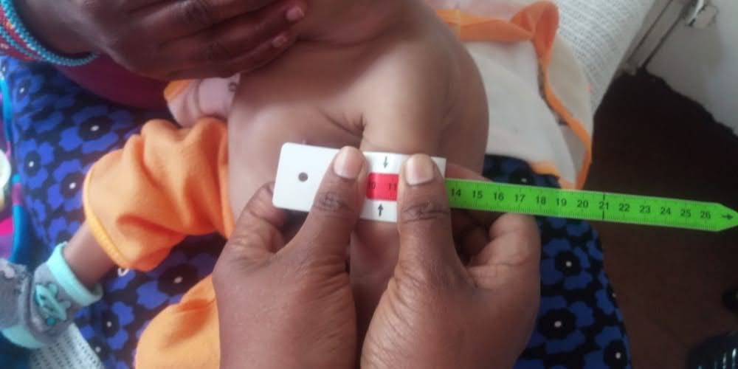
A community health initiative aimed at responding to malnutrition through identification and referral for management.

Chapter 6

IMPLEMENTATION

6.0 Implementation
The implementation of this strategy will be done by the staff with the oversight of the ADSSR board. The board which is at the apex of the organization structure (appendix 1) will provide policy, strategic and oversight role. The Executive Director will provide leadership and will be required to present the progress of the strategy implementation to the board throughout the life of the strategy in line with the pillars. The budgets will also be allocated according to the respective pillars. Where need be, the changes in the operating environment will be considered and the strategy adjusted accordingly. Annual operational plan for year one is captured under annex 2.

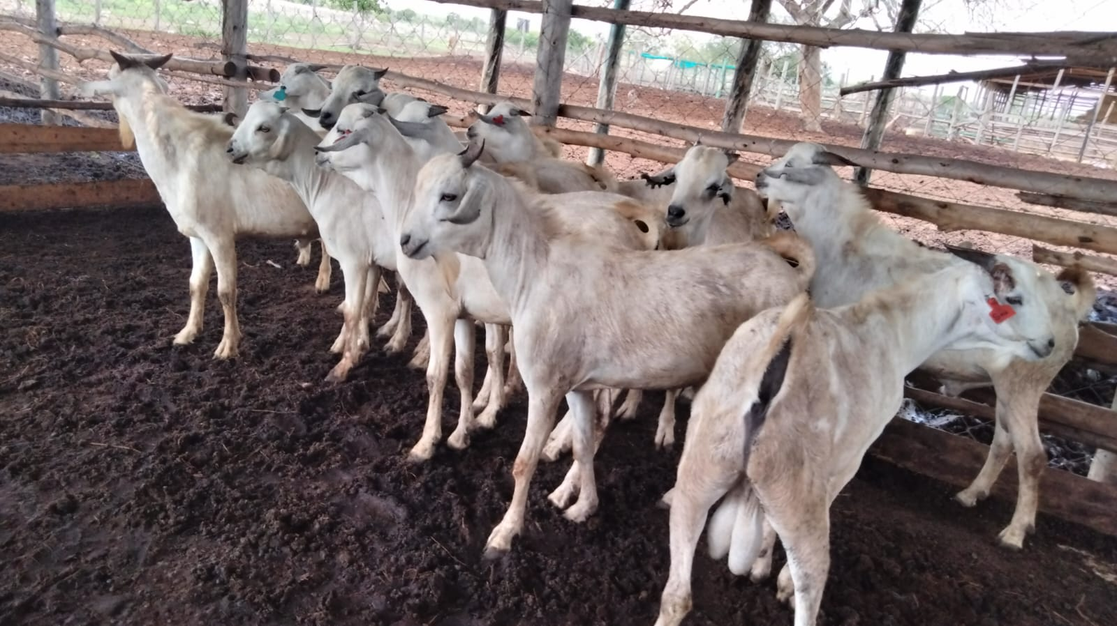
Galla bucks distributed to farmers for breeding

Chapter 7

RESOURCE MOBILIZATION AND FINANCIAL PROJECTIONS

7.1 Introduction
This chapter presents the resources and changes in processes required to realize this strategic plan. It outlines the human and financial, organizational and cultural change. Human resources focus on numbers, efficiency and effectiveness to meet the envisaged targets of this strategic plan.

  - Human Resource
Human resource are central to the attainment of ADS South Rift vision, mission and mandate. Its human resource capacity to effectively carry out the planned activities will determine the extent to which the envisaged targets will be met. Consequently, the management and development of human resources will focus on numbers, efficiency and effectiveness. This will ensure the staff have skills and equipment to deliver this strategy.

  - Staff Capacity Requirements
There is need for a strong Human Resource function within the ADS South Rift, which will work in consultation with the Board to:
- Establish the staff requirement for the entire organization on a regular basis i.e. semi and annual basis.
- Recruit, develop and disengage staff accordingly.
- In consultation with user departments or functions, identify staff training based on ADS South Rift needs and organize appropriate and timely training programmes.
- Implementation of organization capacity assessment report recommendations will be actioned. Action list will be developed and its implementation monitored.
  - Organizational and Culture Change
During the strategic planning process, it was observed that the organization culture needs to change in respect to enforce of policies and decisions agreed upon. In addition, culture of good time management in the life of ADS South Rift Region needs to be institutionalized by all in management.

  - Implementation
To ensure this strategy is implemented, the Board will appoint an implementation committee to ensure that all programs are reported to the board in line with each Pillar during board meetings and stakeholder engagement.

  - Financial Projections and Budget Summary
For successful implementation of the strategic plan the Board will deliberately engage in local financial mobilization aligned to the three strategic pillars. The key sources of finance will include donor funding, contribution in kind, social responsibility, fund raiser and income generating activities. The summary budget under each Pillar is as below:

ADS SOUTH RIFT STRATEGIC PLAN SUMMARY BUDGET 2023-2027
 | PILLAR | AMOUNT KSHS
1. | Community Development Pillar | 394,482,964.00
2 | Institutional Transformation and Sustainability | 30,200,384.20
3. | Property and Investment Pillar | 55,068,593.00
4. | Personnel and Other Overheads | 232,877,899.20
5. | Grand Total | 712,629,791.00

Chapter 8:

RISK ANALYSIS AND CONCLUSION

8.1Risk Analysis
ADSSR like any organization operates in area full of risks and rapid changes. Consequently, management activities will be designed to ensure that Board, management and staff identifies, analyses and respond to the risks that may adversely affect realization of ADSSR mandate and objectives. Management response to risks will depend on the likelihood of the event happening and impact if it does occur. ADSSR based on this risk assessment will need to choose whether to accept, mitigate the risk or transfer the risk to another party. A template focusing on risk areas such governance, project management, staff, reputation, community conflict, IT and financial management will be developed so that risk analysis is done, mitigation measured developed and a person within ADSSR will be assigned the role of risk management. When risk assessment is performed effectively these risk management activities will ensure that the organization limited resources will be prioritised to the most effectively address the issues that will affect them most.

8.2 Conclusion
The 2017-2020(2022) Strategic Plan was implemented during the formation phase of ADS SR (after restructuring from NIDP and TRDP) where much efforts focused on establishment of the initial structures and systems. The 2023-2027 Strategic plan comes during the time when basic structures and systems have been laid and being improved on hence ready to move to a phase of acceleration. It also comes with the change of government in Kenya where the country anticipates new and drastic changes anticipated to accelerate social and economic national development.
It is therefore the rocket that is expected to land the organization to the next height of national and international levels
The plan was developed in a very participatory manner with validation done at various levels. The next focus after launch will be its dissemination to key stakeholders, implementation and resource mobilization.

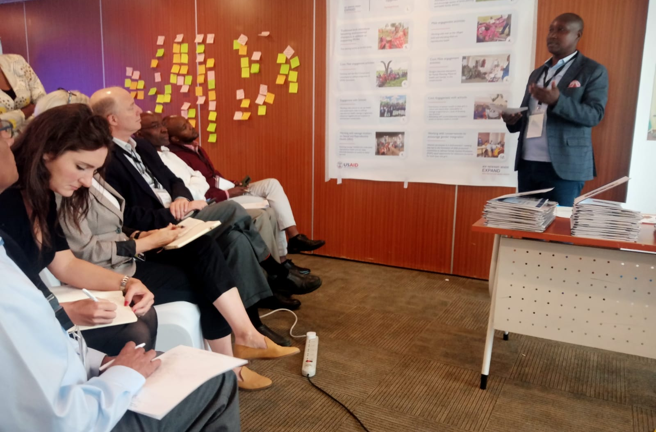
Cross- learning session with USAID NPI partners in Kenya.

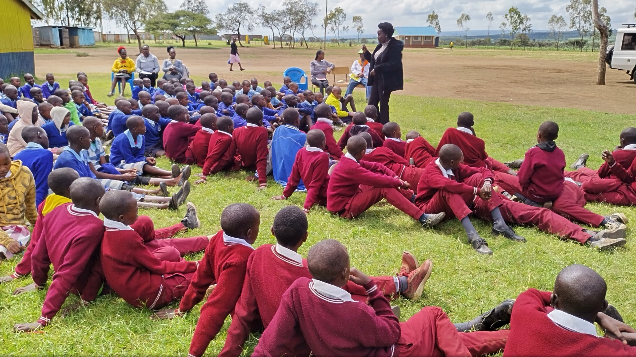
Health and conservation integration session at Nturumeti Primary school.

ANNEXES

Annex 1(a): ADS Southrift Governance Structure

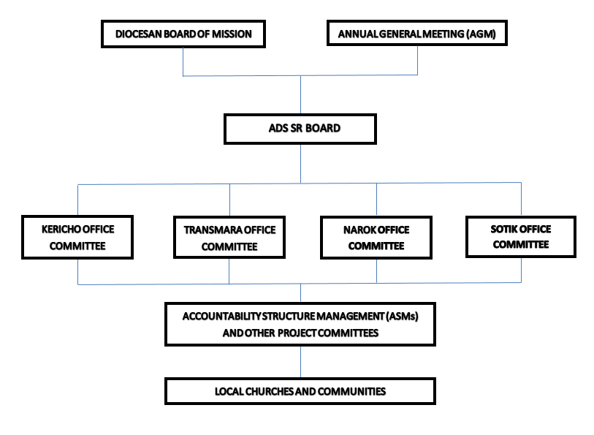

Annex 1(b): ADS Southrift Organizational Structure

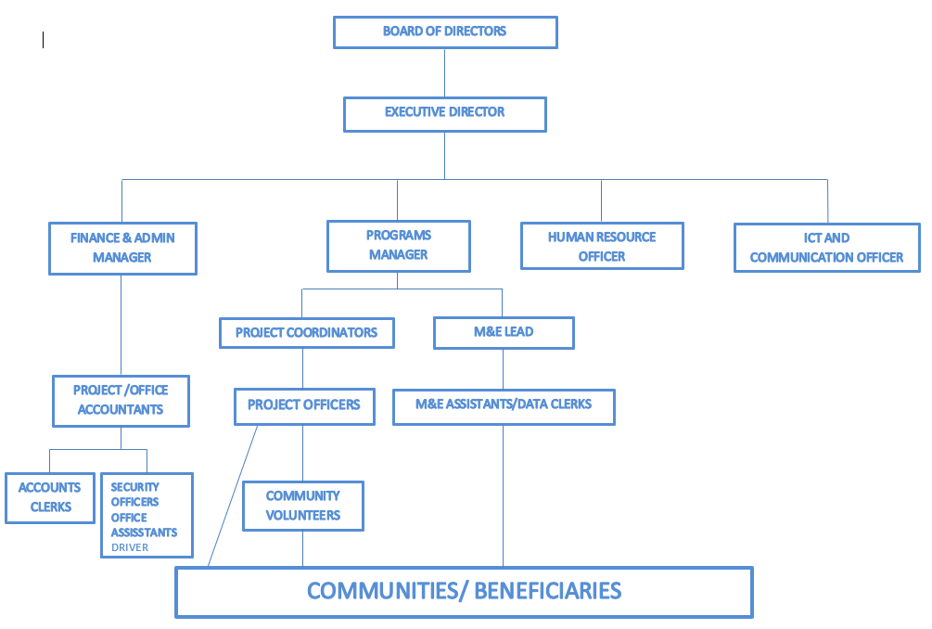

Annex 2: Annual Operational Plan 2023

Pillar 1: Community Development

Table 9: 2023 Annual Operational Plan
ADS SR 2023 Annual Operational Plan

PILLAR 1: COMMUNITY DEVELOPMENT
HUMAN HEALTH
DEMAND CREATION
 |  | JAN | FEB | MAR | APRIL | MAY | JUNE | JULY | AUG | SEP | OCT | NOV | DEC
1.1.1 | Support quarterly community sensitization forums through existing Women, male and youth forums on FP information to dispel myths and misconceptions
1.1.2 | Develop social behavior change and communication materials (SBCC) on FP
1.1.3 | Conduct 3 days training for 120 youth peer educators on SRH and FP to create awareness on FP and SRH
1.1.4 | Train 90 faith leaders through the faith for life model to create awareness on MH& FP
1.1.5 | Engage 90 faith leaders to create awareness on MH& FP
1.1.6 | Conduct three days sensitization for 450 youths on Adolescent Sexual and Reproductive Health /life skills.
1.1.7 | Engage 5000 parents and guardians on Family health and parenting
SERVICE DELIVERY
1.1.8 | Support 30 monthly community integrated outreaches
1.1.9 | Train 300 Health workers on LARC/PPFP to improve clinical skills
1.1.10 | Train 120 Community-based FP Distributed (CBDs)
1.1.11 | Support 120 Community Based Distributors through monthly stipend
1.1.12 | Conduct 30 quarterly support supervisions & mentorship for quality improvement
1.1.13 | Conduct 4 mentorship activities on LARC/PFPP to strengthen clinical skills
1.1.14 | Conduct 10 advocacy meetings with county leadership for improved FP service delivery and resourcing
1.1.15 | Support County/ Sub County Health Management Teams to Participant in development of CIDP and AWP
1.1.16 | Fully immunize 10,000 children under 5 years
1.1.17 | Increase hospital deliveries by 3,000 (mothers)
1.1.18 | Provide post-natal care and Family Planning to 6,000 mothers
1.1.19 | Reach out to 11,000 men with reproductive health messages and services
1.1.20 | Reach out to 20,000 youth and children in and out of school with health messages and services.
1.1.21 | Establish a dispensary in Kericho Archdeaconry
HEALTH INFORMATION MANANAGEMENT SYSTEM
1.1.22 | Conduct quarterly RDQAs for data validation to ensure consistency and accuracy of reported data
1.1.23 | Conduct three days training for 300 health workers on data management to enhance data quality
1.1.24 | Conduct research to support evidence based advocacy and programming in health service delivery
 | Commodity Security
1.1.25 | Support 10 mentorship sessions for health workers along the commodity supply chain to improve commodity forecasting, quantification, accountability and management.
1.1.26 | Support 3 County Commodity Security TWG to provide mentorship and oversight
1.1.27 | Conduct 10 advocacy meetings with county leadership for improved service delivery and resource mobilization
1.1.28 | Conduct 4 Multi-sectorial meeting with county government, relevant sectors and CSOs to strengthen integration and funding for commodities.
HIV AND AIDS
1.1.29 | Conduct training of new # CHVs to provide adherence counseling, defaulter tracing or treatment literacy to PLHIV (Train New CHVs on HCBC)
1.1.30 | Engage new and old CHVs to provide adherence counseling, defaulter tracing or treatment literacy to PLHIV
1.1.31 | Conduct Home visits to PLHIVs by CHVs
1.1.32 | Support groups to enhance disclosure, psychosocial support, adherence and defaulter tracing in the community
1.1.33 | Hold Quarterly facility Review Meetings to enhance community linkage and data review
1.1.34 | Hold monthly data collection fora with CHVs
1.1.35 | Hold Quarterly Review and coordination Meetings with CHVs
1.1.36 | Support Quarterly Data review meetings with CHEWs per Subcounty
1.1.37 | Support Data review for community units and linked facilities, conducted by the SCHMT
1.1.38 | Conduct M&E visits to TCS sites (PLHIV homes, facilities, etc.)
1.1.39 | Participate in stakeholders meetings (County/sub county stakeholders meetings, HIV TWGS etc.)
 | NUTRITION
1.1.40 | Participate during Malezi Bora event
1.1.41 | Support County Nutrition TWG Meetings to effectively coordinate deliver of improved nutrition intervention
1.1.42 | Conduct Community Nutrition sensitization on diet MIYCN for improved feeding practices
1.1.43 | Conduct nutrition education sessions in 90 schools to promote healthy eating and good dietary practices
 | LIVELIHOOOD AND ECONOMIC EMPOWERMENT.
1.2.1 | Establish 30 farmers Field school (F.F.S) groups of 36 households each.
1.2.2 | Establish 120 economic empowerment groups of 3,600 households through Kericho Community Development Trust (KCDT)
1.2.3 | Empower 5000 households by establishing 250 groups of 20 members each through the ADS SR site offices.
1.2.4 | Enhance dairy farming in Manaret and Narok and centralized milk sale business in both places
1.2.5 | Establish 2 irrigation schemes at Olkeri parish and Erupata
1.2.6 | Enhance food security among 5000 households in South Rift region through climate smart Agriculture-Beans Value chain.
 | CLIMATE CHANGE
1.3.1 | Build capacity of 500 of ToTS through training on environmental stewardship
1.3.2 | Facilitate 240 community awareness forums on climate change adaptation.
1.3.3 | Formulate and adopt policies on climate change adaptation by observing environmental weeks and tree planting during Diocesan events.
1.3.4 | Establish community tree nurseries in 4 Archdeaconry
1.3.5 | Train 30 clergy,60 staff and community members on disaster preparedness, Disaster Risk Reduction and response
1.3.6 | Be a member of the likeminded environmental movements
1.3.7 | Develop policy on tree planting in 10 per cent of church land and lands owned by church- sponsored institutions.
1.3.8 | Incorporate 200 schools within the South Rift Region on environmental conservation interventions.
1.3.9 | Drill 10 Boreholes
1.3.10 | Establish water harvesting technics (10 water pans, 500 tanks)
 | PEACE BUILDING
1.4.1 | Conduct 20 peace building forums among communities living South Rift region
1.4.2 | Organize Annual ADSSR Marathon and 10 football and Volley ball matches to enhance peaceful coexistence among communities
1.4.3 | Support and facilitate 4 advocacy initiative to resolve conflicts
1.4.4 | Facilitate staff and clergy capacity building to enhance ability to resolve conflicts
1.4.5 | Foster and strengthen partnership with expert organizations in peace building and conflict resolution.
1.4.6 | Map out the hot spot areas
1.4.7 | Identify and encourage peace structures
 | ADVOCACY
1.5.1 | Train and build the capacities of individuals and communities to meaningfully participate in decision making forums
1.5.2 | Support 250 quarterly community awareness creation forums
1.5.3 | Disseminate laws and regulations against Gender Based and Domestic Violence, Child protection laws.
1.5.4 | Identify and work with likeminded partners to carry out advocacy interventions
1.5.5 | Lobby local Government authorities to pass laws that protect the vulnerable
1.5.6 | Participate jointly as ADS SS region in marking of Key International/ World/National Days
1.5.7 | Develop ADS SR advocacy plan
1.5.8 | Participate in budgeting process social audit in County Government
 | CAPACITY BUlLDING
 | CCMP APPROACH
1.6.1 | Design and conduct Bible studies in 60 churches
1.6.2 | Facilitate steward trainings in 100 local churches
1.6.3 | Envisioning local church capacity development programmes
1.6.4 | Participate in Monitoring and evaluation
 | Other approaches rooted in Jesus, Church departments -Mothers Union, Children Ministries, Compassion Sundays
 | OVC CARE AND SUPPORT
1.7.1 | Enroll 2,200 new OVC (7000-4,800) to OVC program
1.7.2 | Support OVC core services for 7,000 OVCs by offering education, food and nutrition, shelter, economic empowerment, psychosocial support, protection, and health care services.
1.7.3 | Support referral and linkages for services
1.7.4 | Engage the Church to support OVC work
1.7.5 | Link the needy children in church with OVC programs.
 | PARTICIPATORY MONITORING, EVALUATION AND LEARNING (PMEL)
1.8.1 | Conduct baseline study and End line survey for all projects
1.8.2 | Conduct quarterly RDQAs to validate the accuracy, reliability, completeness, consistency and availability of reports/ data submitted
1.8.3 | Conduct Monthly review meetings to monitor project progress and address emerging challenges during implementation
1.8.4 | Conduct quarterly review meetings at Sub county/County level
1.8.5 | Support Monthly data Collection of program reports
1.8.6 | Conduct quarterly Support supervisions & mentorship for quality improvement
1.8.7 | Conduct quarterly M&E visits to assess programmes progress
1.8.8 | Conduct monthly staff and planning meetings
1.8.9 | Documentation of success stories and Best practices
1.8.10 | Develop tools for Data Collection
1.8.11 | Reporting
 | EMERGENCY RESPONSE
1.9.1 | Train TOTs (30 Clergy and 40 staff) on disaster preparedness
1.9.2 | Conduct 100 community sensitization forums on disaster preparedness
1.9.3 | Establish an emergency fund for ADS SR
1.9.4 | Capacity building of staff and clergy on core humanitarian standards (CHS)
1.9.5 | Establish an emergency response team
 | GENDER AND DISABILITY MAINSTREAMING
1.10.1 | Disseminate policies and laws that promote gender equality.
1.10.2 | Capacity building of staff, and clergy on gender and disability mainstreaming
1.10.3 | Sensitization of community members to reduce stereotypes and increase participation and representation in decision making fora.
1.10.4 | Partner with the Department of Health and National Council for Persons with Disability (NCPWD) for registration and placement of Persons with Disability
1.10.5 | Facilitate advocacy trainings to reduce stereotypes, increase participation and representation
1.10.6 | Training of teachers and all staff of the ACK schools on disability and inclusion
1.10.7 | Advocate for inclusion of special facilities in schools, Hotels, Churches to make them disability- friendly.
1.10.8 | Link and refer persons with disability for assistive devices including visual impairment guides, braile, wheel chairs, clutches etc
1.10.9 | Advocate for a sign language interpreter in churches
1.10.10 | Train staff and clergy on sign language
1.10.11 | Support Gender Sector Technical working group meetings

Pillar 2: Organizational Transformation and Sustainability

Table 10: Annual Operational Plan
Description |  |  | Period (2024)
Strategic areas | Strategic Objective | Activity | Jan | Feb | March | April | May | June | July | Aug | Sept | Oct | Nov | Dec
Governance | Strengthened ADSSR board and program committee to comply and provide oversight | Establish OCA implementation and review framework
Governance |  | Restructure the board & program committee to reflect Gender, Disability and Professional skills and expertise
Governance |  | Train ADSSSR Board & Program committee to effectively perform their oversight roles
Governance |  | Establish and review existing policies and manuals to ensure statutory compliance and best practices (Safeguarding, risk, whistle blowing, health and safety, complain and feedback mechanism and code of conduct, data protection plan among others
Governance |  | Establish an organization policy inventory
Governance |  | Support Board & program committees to conduct at least four meeting
HR Management & Development | 2.2 Recruit, Motivate and retain a result oriented workforce | 1. Recruit adequate staff to ensure proper segregation of duties at ADS Secretariat & Program level
HR Management & Development | 2.2 Recruit, Motivate and retain a result oriented workforce | 2. Support continuous staff training and development
HR Management & Development | 2.2 Recruit, Motivate and retain a result oriented workforce | 3. Develop a proper appraisal and succession manual
HR Management & Development | 2.2 Recruit, Motivate and retain a result oriented workforce | 4. Establish & Support staff motivation through salary increment, promotions, team building and annual staff of the year recognition
Financial Management | 2.3 Enhance Resource mobilization and optimization to achieve organization mandate | 1. Develop a resource mobilization strategy
Financial Management |  | 2. Establish a resource mobilization desk/team
Financial Management |  | 3. Sustainability and other enabler projects to contribute 20% of their generated revenue to support the social mission of ADS-SR (Framework)
Financial Management |  | 4. Develop a centralized accounting financial system with adequate backup.
Financial Management |  | 5.Develop centralized coded chart of accounts for ease of consolidation
Financial Management |  | 6. Continuously assess the existing internal control to minimize risk
Financial Management |  | 7. Maintained a consolidated tagged assent register
Financial Management |  | 8. Automate financial services through ERS
Financial Management |  | 9. Conduct project and institutional audit & develop audit action list
Financial Management |  | 10. Hire an IT/Communication Staff to maintain the network system; allocate system access rights and organization’s Website
Procurement |  | 1. Establish a procurement policy
Procurement |  | 2. Establishment of functional tendering committees
Organization structure | 2.4 Well documented and communicated organizational structure | 1. Undertake Organization structure review to define Communication and reporting protocols
Participatory Monitoring, Evaluation and learning. | 2.5 Well managed project with structures to ensure proper planning and implementation of program activities. | 1. Develop an M&E system to adequately track project implementation.
Participatory Monitoring, Evaluation and learning. |  | 2. Set -up a functional Monitoring and Evaluation Monitoring and Learning team
Participatory Monitoring, Evaluation and learning. |  | 3. Develop both a Monitoring and Evaluation (M & E) and Monitoring and Learning plan (MEL)
Participatory Monitoring, Evaluation and learning. |  | 4. Develop an M&E policy and implementation plan.
Risk Management | 2.6 Safeguard stakeholders interest | 1. Develop a risk management policy
Risk Management | 2.6 Safeguard stakeholders interest | 2. Establish and continuously assess statutory, safety and workmanship organization compliance
Risk Management | 2.6 Safeguard stakeholders interest | 3. Sensitize staff on risk mitigation areas
Risk Management | 2.6 Safeguard stakeholders interest | 4. Insure organization properties and assets against risk (fire, theft, political & violence)

Pillar 3: Property and Investment

Table 11: Annual Operational plan 2023
 | Activity | Jan | Feb | Mar | Apr | May | June | Jul | Aug | Sep | Oct | Nov | Dec
 | Business development:
3.1 | To increase ADS SR unrestricted funds by 30% by 2027
3.1.1 | Develop a Centralized business management plan for the ADS SR businesses including Guest houses, rental houses/offices, dispensaries
3.1.2 | Construct Narok Guest house conference facility phase 2 (1st floor and restaurant
3.1.3 | Buy land and construct 5 rental units in Trans Mara
3.1.4 | Commercialize 2 health facilities in Nturumeti, Olendeem to be profit making
3.1.5 | Establish 50 acres pasture farm project in Transmara and Narok
3.1.6 | Establish a goats farming project in Mara with 100 goats
3.1.7 | Increase the number of tents from 15 to 30 and equip the facility, construct 1 conference hall, 1vehicle, swimming pool and a chapel
3.1.8 | Develop and implement property and investment policy
3.2 | Asset management: To improve organizational asset management
3.2.1 | Develop an asset management policy
3.3 | Risk Management: To increase awareness and mitigation of potential risks
3.3.1 | Develop a risk management policy
3.4 | Compliance: To comply to all government requirements in running the ADS SR businesses
3.4.1 | Register, subscribe and comply with all the required bodies and legal requirements- Public Health, VAT, PAYE, Housing, NCA, Disability, labor laws, Occupational safety.
3.4.2 | Train staff on compliance
3.5 | Resource Mobilization: To increase the organizational funding base to meet the strategic plan budget
3.5.1 | Document and strengthen resource mobilization team
3.5.2 | Set up and utilize a fundraising portal in our website
3.5.3 | Partnership with the diocese to utilize idle land
3.5.4 | Strengthen the loan recovery component of FFS from 35% to 90%
3.6 | Monitoring and evaluation: To increase accountability and management of ADS South Rift business enterprises
3.6.1 | Develop a monitoring and evaluation plan for the investment
3.6.2 | Evaluate performance
3.6.3 | Develop and analyze financial reports regularly depending on the business
3.6.4 | Develop Service charter for the businesses and monitor quality of services regularly
3.6.5 | Provide service feedback mechanisms through suggestion boxes, phone call and evaluation forms.
3.6.6 | Develop reporting tools for the businesses
3.6.7 | Recruit a professional business development manager
3.6.8 | Set up an adhoc committee to monitor businesses

Annex 3: ADS Southrift Total Estimated Cost 2023-2027 in Kenya Shillings

Detailed Budget
Period of Performance: |  |  |  |  | 1 Year | 2 Year | 3 Year | 4 Year | 5 Year | Total
Line Item / Description | Unit | Frequency | Units | Cost/ Unit | Cost
ADMINISTRATIVE COSTS
PERSONNEL
1.1 ADSSR Secretariate Staffs
1.1.1 ADSSR Executive Director | Monthly | 12 | 12 | 184,202 | 2,210,428 | 2,431,471 | 2,674,618 | 2,942,080 | 3,236,288 | 13,494,883.74
1.1.2 ADSSR Human Resource Manager | Monthly | 12 | 12 | 128,100 | 1,537,200 | 1,690,920 | 1,860,012 | 2,046,013 | 2,250,615 | 9,384,759.72
1.1.3 ADSSR Finance Manager | Monthly | 12 | 12 | 128,100 | 1,537,200 | 1,690,920 | 1,860,012 | 2,046,013 | 2,250,615 | 9,384,759.72
1.1.4 ADSSR Monitoring Evaluation and Learning Lead | Monthly | 12 | 12 | 128,100 | 1,537,200 | 1,690,920 | 1,860,012 | 2,046,013 | 2,250,615 | 9,384,759.72
1.1.5 ADSSR Program Lead | Monthly | 12 | 12 | 136,662 | 1,639,942 | 1,803,936 | 1,984,330 | 2,182,763 | 2,401,039 | 10,012,009.66
1.1.6 ADSSR ICT Lead | Monthly | 12 | 12 | 101,400 | 1,216,800 | 1,338,480 | 1,472,328 | 1,619,561 | 1,781,517 | 7,428,685.68
1.1.7 ADSSR Procurement and Admin | Monthly | 12 | 12 | 101,400 | 1,216,800 | 1,338,480 | 1,472,328 | 1,619,561 | 1,781,517 | 7,428,685.68
1.2 ADSSR Implementation staffs |  |  |  |  |  |  |  |  |  | -
1.2.1. Program Team leaders (1 staffs for each Site light Office) | Monthly | 12 | 36 | 130,662 | 4,703,826 | 5,174,208 | 5,691,629 | 6,260,792 | 6,886,871 | 28,717,327.38
1.2.2. Project Coordinators (1 staffs for each Site light Office) | Monthly | 12 | 36 | 125,100 | 4,503,600 | 4,953,960 | 5,449,356 | 5,994,292 | 6,593,721 | 27,494,928.36
1.2.3 Project Officers (3 staffs for each Site light Office) | Monthly | 12 | 108 | 89,980 | 9,717,849 | 10,689,634 | 11,758,597 | 12,934,457 | 14,227,902 | 59,328,437.73
1.2.3 Monitoring & Evaluation Officer | Monthly | 12 | 24 | 89,937 | 2,158,478 | 2,374,326 | 2,611,758 | 2,872,934 | 3,160,228 | 13,177,723.55
1.2.4 Project Accountants (1 staffs for each Site light Office) | Monthly | 12 | 36 | 84,922 | 3,057,198 | 3,362,918 | 3,699,209 | 4,069,130 | 4,476,043 | 18,664,498.78
TOTAL PERSONNEL |  |  |  | 1,428,565 | 35,036,520 | 38,540,172 | 42,394,189 | 46,633,608 | 51,296,969 | 213,901,459.72
OTHER ADMIN
Travels and Per diems
Mileages, Fuel and staffs Lunches
Mileage charged on hired vehicles | Monthly |  | 72 | 9,000 | 648,000 | 712,800 | 712,800 | 712,800 | 784,080 | 3,570,480.00
Staffs lunches | Monthly |  | 36 | 3,000 | 108,000 | 118,800 | 118,800 | 118,800 | 130,680 | 595,080.00
Subtotal, Mileages, Fuel and staffs Lunches: |  |  |  |  | 756,000 | 831,600 | 831,600 | 831,600 | 914,760 | 4,165,560.00
Project Office Costs |  |  |  |  |  |  |  |  |  | -
Office space/ Rent | /month |  | 12 | 20,000 | 240,000 | 264,000 | 264,000 | 264,000 | 290,400 | 1,322,400.00
Office Utilities: water and electricity | /month |  | 12 | 24,000 | 288,000 | 316,800 | 316,800 | 316,800 | 348,480 | 1,586,880.00
Office consumables | /month |  | 12 | 24,000 | 288,000 | 316,800 | 316,800 | 316,800 | 348,480 | 1,586,880.00
Office cleaning services | /month |  | 12 | 20,000 | 240,000 | 264,000 | 264,000 | 264,000 | 290,400 | 1,322,400.00
Security services | /month |  | 12 | 24,000 | 288,000 | 316,800 | 316,800 | 316,800 | 348,480 | 1,586,880.00
Office Stationaries | /month |  | 12 | 28,000 | 336,000 | 369,600 | 369,600 | 369,600 | 406,560 | 1,851,360.00
Office equipment Insurance | /year |  | 12 | 10,000 | 120,000 | 132,000 | 132,000 | 132,000 | 145,200 | 661,200.00
Bank charges | /month |  | 12 | 2,000 | 24,000 | 26,400 | 26,400 | 26,400 | 29,040 | 132,240.00
Subtotal, Country Office Project Office Costs: |  |  |  |  | 1,824,000 | 2,006,400 | 2,006,400 | 2,006,400 | 2,207,040 | 10,050,240.00
Communication Costs
Office Internet cost | /month |  | 12 | 20,000 | 240,000 | 264,000 | 264,000 | 264,000 | 290,400 | 1,322,400.00
Staffs monthly Airtime | /month |  | 12 | 50,000 | 600,000 | 660,000 | 660,000 | 660,000 | 726,000 | 3,306,000.00
Postage fees | /month |  | 12 | 2,000 | 24,000 | 26,400 | 26,400 | 26,400 | 29,040 | 132,240.00
Subtotal, Country Office Communication Costs: |  |  |  |  | 864,000 | 950,400 | 950,400 | 950,400 | 1,045,440 | 4,760,640.00
TOTAL, OTHER DIRECT COSTS: |  |  |  |  | 38,480,520 | 42,328,572 | 46,182,589 | 50,422,008 | 55,464,209 | 232,877,899.72
TOTAL HR and ADMIN COSTS |  |  |  |  | 38,480,520 | 42,328,572 | 46,182,589 | 50,422,008 | 55,464,209 | 232,877,899.72
Pillar 1: Community Development

To increase access to quality healthcare in South Rift region by December 2027

1.1. 0 MCH/FP Demand Creation |  |  |  |  |  |  |  |  |  | -
1.1.1 Support Quarterly community sensitization forums through existing Women, men and youth forums to provide FP information & dispel myths and misconceptions |  |  |  |  |  |  |  |  |  | -
Community Forum cost, Transport, MOH facilitation, staff lunches | Forums | 4 | 18 | 19,000 | 1,368,000 | 1,504,800 | 1,655,280 | 1,820,808 | 2,002,889 | 8,351,776.80
1.1.2 Develop social behavior change and communication materials (SBCC) on FP |  |  |  |  |  |  |  |  |  | -
Printing costs for 5000 copies per year @50 | copy | 1 | 50 | 5,000 | 250,000 | 275,000 | 302,500 | 332,750 | 366,025 | 1,526,275.00
1.1.3 Train 120 youth peer educators on SRH and FP to create awareness on FP and SRH |  |  |  |  |  | - |  | - |  | -
Training cost, Conference cost, facilitation, transport | Training | 1 | 24 | 96,420 | 2,314,080 | 2,545,488 | 2,800,037 | 3,080,040 | 3,388,045 | 14,127,689.81
Photocopy services | Pax | 1 | 1 | 10,000 | 10,000 | 11,000 | 12,100 | 13,310 | 14,641 | 61,051.00
Identification Badges | Pax | 1 | 24 | 200 | 4,800 | 5,280 | 5,808 | 6,389 | 7,028 | 29,304.48
CBD Tool bags | Pax | 1 | 24 | 2,000 | 48,000 | 52,800 | 58,080 | 63,888 | 70,277 | 293,044.80
CBDs Branded Jacket & Cap-Dustcoat | Pax | 1 | 24 | 2,500 | 60,000 | 66,000 | 72,600 | 79,860 | 87,846 | 366,306.00
1.1.4 Train 90 faith leaders through the faith for life model to create awareness on MH& FP | Training |  |  |  |  |  |  |  |  | -
Mobilization cost | Pax | 1 | 1 | 6,000 | 6,000 | 6,600 | 7,260 | 7,986 | 8,785 | 36,630.60
Facilitation fee (County & National) | Pax | 1 | 1 | 25,000 | 25,000 | 27,500 | 30,250 | 33,275 | 36,603 | 152,627.50
Full Board Conference cost | Pax | 1 | 18 | 15,000 | 270,000 | 297,000 | 326,700 | 359,370 | 395,307 | 1,648,377.00
Transport reimbursement | Pax | 1 | 18 | 2,000 | 36,000 | 39,600 | 43,560 | 47,916 | 52,708 | 219,783.60
Hall Hire & stationaries | venue | 1 | 5 | 3,000 | 15,000 | 16,500 | 18,150 | 19,965 | 21,962 | 91,576.50
Transport (Mileage cost) | Mileage | 1 | 6 | 12,000 | 72,000 | 79,200 | 87,120 | 95,832 | 105,415 | 439,567.20
1.1.5 Engage 90 faith leaders to create awareness on MH& FP | Meetings |  |  |  |  |  |  |  |  | -
Mobilization cost | Pax | 4 | 18 | 1,000 | 72,000 | 79,200 | 87,120 | 95,832 | 105,415 | 439,567.20
Transport reimbursement | Pax | 4 | 18 | 2,000 | 144,000 | 158,400 | 174,240 | 191,664 | 210,830 | 879,134.40
Transport (Mileage cost) | Mileage | 4 | 6 | 12,000 | 288,000 | 316,800 | 348,480 | 383,328 | 421,661 | 1,758,268.80
1.1.6 Sensitize 450 youths on Adolescent Sexual and Reproductive Health and life skills. |  |  |  |  |  |  |  |  |  | -
Mobilization cost | Pax | 1 | 3 | 3,000 | 9,000 | 9,900 | 10,890 | 11,979 | 13,177 | 54,945.90
Facilitation fee (County & National) | Pax | 1 | 3 | 45,000 | 135,000 | 148,500 | 163,350 | 179,685 | 197,654 | 824,188.50
Full Board Conference cost | Pax | 1 | 90 | 9,000 | 810,000 | 891,000 | 980,100 | 1,078,110 | 1,185,921 | 4,945,131.00
Transport reimbursement | Pax | 1 | 90 | 2,000 | 180,000 | 198,000 | 217,800 | 239,580 | 263,538 | 1,098,918.00
Hall Hire & stationaries | Venue | 1 | 3 | 15,000 | 45,000 | 49,500 | 54,450 | 59,895 | 65,885 | 274,729.50
Transport (Mileage cost) | Mileage | 1 | 9 | 12,000 | 108,000 | 118,800 | 130,680 | 143,748 | 158,123 | 659,350.80
1.1.7 Engage parents and guardians on Family health and parenting |  |  |  |  |  |  |  |  |  | -
Mobilization | Forum | 2 | 9 | 3,000 | 54,000 | 59,400 | 65,340 | 71,874 | 79,061 | 329,675.40
Facilitation | Forum | 2 | 9 | 6,000 | 108,000 | 118,800 | 130,680 | 143,748 | 158,123 | 659,350.80
Transport (Mileage cost) | Mileage | 2 | 9 | 12,000 | 216,000 | 237,600 | 261,360 | 287,496 | 316,246 | 1,318,701.60
Sub Total FP/MCH Demand Creation |  |  |  |  | 6,647,880 | 7,312,668 | 8,043,935 | 8,848,328 | 9,733,161 | 40,585,972.19
1.1.2: Service delivery | -
1.2.1 Support 30 monthly community integrated outreaches |  |  |  |  |  |  |  |  |  | -
Community Forum cost, Transport, MOH facilitation, staff lunches | Forums | 12 | 60 | 5,000 | 3,600,000 | 3,960,000 | 4,356,000 | 4,791,600 | 5,270,760 | 21,978,360.00
1.1.2 Train 300 Health workers on LARC/PPFP to improve FP clinical & Counseling skills |  |  |  |  |  |  |  |  |  | -
Mobilization cost | Pax | 1 | 3 | 3,000 | 9,000 | 9,900 | 10,890 | 11,979 | 13,177 | 54,945.90
MOH Facilitation fee | pax | 1 | 3 | 50,000 | 150,000 | 165,000 | 181,500 | 199,650 | 219,615 | 915,765.00
Full Board Conference cost | pax | 1 | 60 | 15,000 | 900,000 | 990,000 | 1,089,000 | 1,197,900 | 1,317,690 | 5,494,590.00
Transport reimbursement | pax | 1 | 60 | 2,000 | 120,000 | 132,000 | 145,200 | 159,720 | 175,692 | 732,612.00
Hall Hire & stationaries | Venue | 1 | 3 | 3,000 | 9,000 | 9,900 | 10,890 | 11,979 | 13,177 | 54,945.90
Transport (Mileage cost) | Mileage | 1 | 3 | 12,000 | 36,000 | 39,600 | 43,560 | 47,916 | 52,708 | 219,783.60
1.2.3 Train 120 Community-based FP Distributed (CBDs) | Training |  |  |  |  |  |  |  |  | -
Training cost, Conference cost, facilitation, transport | Pax | 1 | 24 | 96,420 | 2,314,080 | 2,545,488 | 2,800,037 | 3,080,040 | 3,388,045 | 14,127,689.81
Photocopy services | Pax | 1 | 1 | 10,000 | 10,000 | 11,000 | 12,100 | 13,310 | 14,641 | 61,051.00
Identification Badges | Pax | 1 | 24 | 200 | 4,800 | 5,280 | 5,808 | 6,389 | 7,028 | 29,304.48
CBD Tool bags | Pax | 1 | 24 | 2,000 | 48,000 | 52,800 | 58,080 | 63,888 | 70,277 | 293,044.80
CBDs Branded Jacket & Cap-Dustcoat | Pax | 1 | 24 | 2,500 | 60,000 | 66,000 | 72,600 | 79,860 | 87,846 | 366,306.00
1.1.4 Support 120 Community Based Distributors through monthly stipend |  |  |  |  |  |  |  |  |  | -
CBDs Monthly stipend | pax | 12 | 24 | 2,500 | 720,000 | 792,000 | 871,200 | 958,320 | 1,054,152 | 4,395,672.00
CBDs monthly transport Reimbursement | pax | 12 | 24 | 500 | 144,000 | 158,400 | 174,240 | 191,664 | 210,830 | 879,134.40
Transport (Mileage cost) | pax | 12 | 4 | 12,000 | 576,000 | 633,600 | 696,960 | 766,656 | 843,322 | 3,516,537.60
1.2.5 Conduct 30 quarterly support supervisions & mentorship for quality improvement |  |  |  |  |  |  |  |  |  | -
Facilitation cost | pax | 4 | 30 | 15,000 | 1,800,000 | 1,980,000 | 2,178,000 | 2,395,800 | 2,635,380 | 10,989,180.00
Transport (Mileage cost) | Mileage | 4 | 10 | 12,000 | 480,000 | 528,000 | 580,800 | 638,880 | 702,768 | 2,930,448.00
1.1.6 Conduct mentorship on LARC/PFPP to strengthen clinical skills targeting 90 HW |  |  |  |  |  |  |  |  |  | -
Training cost, Conference cost, facilitation, transport | Training | 1 | 18 | 19,500 | 351,000 | 386,100 | 424,710 | 467,181 | 513,899 | 2,142,890.10
Transport (Mileage cost) | Mileage | 1 | 6 | 12,000 | 72,000 | 79,200 | 87,120 | 95,832 | 105,415 | 439,567.20
1.1.7 Conduct 15 advocacy meetings with county leadership for improved FP prioritization and resourcing |  |  |  |  |  |  |  |  |  | -
Meeting cost, Conference cost, facilitation, transport | Meeting | 1 | 20 | 8,975 | 179,500 | 197,450 | 217,195 | 238,915 | 262,806 | 1,095,865.45
Transport (Mileage cost) | Mileage | 1 | 3 | 12,000 | 36,000 | 39,600 | 43,560 | 47,916 | 52,708 | 219,783.60
1.1.8 Support County & Sub County Health Management Teams to Participant in development and implementation of CIDP and AWP |  |  |  |  |  |  |  |  |  | -
Meeting cost, Conference cost, facilitation, transport | Meeting | 1 | 20 | 5,825 | 116,500 | 128,150 | 140,965 | 155,062 | 170,568 | 711,244.15
Transport (Mileage cost) | Mileage | 1 | 3 | 12,000 | 36,000 | 39,600 | 43,560 | 47,916 | 52,708 | 219,783.60
Sub Total Service Delivery |  |  |  |  | 11,771,880 | 12,949,068 | 14,243,975 | 15,668,372 | 17,235,210 | 71,868,504.59
1.3 Health Information management |  |  |  |  |  |  |  |  |  | -
1.3.1 Conduct quarterly RDQAs for data validation to ensure consistency and accuracy of reported data |  |  |  |  |  |  |  |  |  | -
Facilitation cost | Meeting | 4 | 18 | 15,000.00 | 1,080,000 | 1,188,000 | 1,306,800 | 1,437,480 | 1,581,228 | 6,593,508.00
Transport (Mileage cost) | Mileage | 4 | 6 | 12,000.00 | 288,000 | 316,800 | 348,480 | 383,328 | 421,661 | 1,758,268.80
1.3.2 Train 300 health workers on data management to enhance FP data quality |  |  |  |  |  |  |  |  |  | -
Training cost, Conference cost, facilitation, transport | Training | 1 | 60 | 12,800 | 768,000 | 844,800 | 929,280 | 1,022,208 | 1,124,429 | 4,688,716.80
Transport (Mileage cost) | Mileage | 1 | 3 | 12,000 | 36,000 | 39,600 | 43,560 | 47,916 | 52,708 | 219,783.60
1.3.3 Conduct research to support evidence-based advocacy and programming in FP and SRH |  |  |  |  |  |  |  |  |  | -
Consultancy Fee | Survey | 1 | 1 | 400,000 | 400,000 | 440,000 | 484,000 | 532,400 | 585,640 | 2,442,040.00
Subtotal 1.3 |  |  |  |  | 2,572,000 | 2,829,200 | 3,112,120 | 3,423,332 | 3,765,665 | 15,702,317.20
1.4: Commodity security |  |  |  |  |  |  |  |  |  | -
1.4.1 Support mentorship of 90 health workers along the FP Commodity supply chain to improve commodity forecasting, quantification, accountability and management. |  |  |  |  |  |  |  |  |  | -
Training cost, Conference cost, facilitation, transport | Training | 1 | 18 | 7,100 | 127,800 | 140,580 | 154,638 | 170,102 | 187,112 | 780,231.78
Transport (Mileage cost) | Mileage | 1 | 3 | 12,000 | 36,000 | 39,600 | 43,560 | 47,916 | 52,708 | 219,783.60
1.4.2 Support 3 County Commodity Security TWG to provide mentorship and oversight |  |  |  |  |  |  |  |  |  | -
Facilitation cost | Pax | 2 | 3 | 9,000.00 | 54,000 | 59,400 | 65,340 | 71,874 | 79,061 | 329,675.40
Transport Reimbursement | pax | 2 | 30 | 2,000.00 | 120,000 | 132,000 | 145,200 | 159,720 | 175,692 | 732,612.00
Day Conference package | pax | 2 | 30 | 1,500.00 | 90,000 | 99,000 | 108,900 | 119,790 | 131,769 | 549,459.00
Transport (Millage cost) | Mileage | 2 | 3 | 3,000.00 | 18,000 | 19,800 | 21,780 | 23,958 | 26,354 | 109,891.80
1.4.3 Conduct 15 advocacy meetings with county leadership for improved FP service delivery and resource mobilization |  |  |  |  |  |  |  |  |  | -
Meeting cost, Conference cost, facilitation, transport | Meeting | 1 | 20 | 9,200 | 184,000 | 202,400 | 222,640 | 244,904 | 269,394 | 1,123,338.40
Transport (Mileage cost) | Mileage | 1 | 3 | 12,000 | 36,000 | 39,600 | 43,560 | 47,916 | 52,708 | 219,783.60
1.4.4. Conduct 15 Multi-sectoral meeting with county government, relevant sectors and CSOs to strengthen integration and funding for FP. |  |  |  |  |  |  |  |  |  | -
Meeting cost, Conference cost, facilitation, transport | Meeting | 1 | 20 | 5,100 | 102,000 | 112,200 | 123,420 | 135,762 | 149,338 | 622,720.20
Transport (Mileage cost) | Mileage | 1 | 3 | 12,000 | 36,000 | 39,600 | 43,560 | 47,916 | 52,708 | 219,783.60
 |  |  |  |  | 803,800 | 884,180 | 972,598 | 1,069,858 | 1,176,844 | 4,907,279.38
1.5: HIV AND AIDs |  |  |  |  |  |  |  |  |  | -
1.5.1 Conduct training of new 100 CHVs to provide adherence counselling, defaulter tracing or treatment literacy to PLHIV (Train New CHVs on HCBC) |  |  |  |  |  |  |  |  |  | -
Training cost, Conference cost, facilitation, transport | Training | 3 | 20 | 12,800 | 768,000 | 844,800 | 929,280 | 1,022,208 | 1,124,429 | 4,688,716.80
Transport (Mileage cost) | Mileage | 3 | 3 | 12,000 | 108,000 | 118,800 | 130,680 | 143,748 | 158,123 | 659,350.80
1.5.2 Engage new and old CHVs to provide adherence counselling, defaulter tracing or treatment literacy to PLHIV |  |  |  |  |  |  |  |  |  | -
CHVs Monthly stipend | pax | 12 | 40 | 2,500 | 1,200,000 | 1,320,000 | 1,452,000 | 1,597,200 | 1,756,920 | 7,326,120.00
CHVs Monthly transport Reimbursement | pax | 12 | 3 | 500 | 18,000 | 19,800 | 21,780 | 23,958 | 26,354 | 109,891.80
Transport (Mileage cost) | pax | 12 | 4 | 12,000 | 576,000 | 633,600 | 696,960 | 766,656 | 843,322 | 3,516,537.60
1.5.3 Conduct Home visits to PLHIVs by CHVs |  |  |  |  |  |  |  |  |  | -
Transport (Mileage cost) | Mileage | 3 | 30 | 12,000 | 1,080,000 | 1,188,000 | 1,306,800 | 1,437,480 | 1,581,228 | 6,593,508.00
1.5.4 Support groups to enhance disclosure, psychosocial support, adherence and defaulter tracing in the community |  |  |  |  |  |  |  |  |  | -
Meeting cost, Conference cost, facilitation, transport | Meeting | 1 | 80 | 9,100 | 728,000 | 800,800 | 880,880 | 968,968 | 1,065,865 | 4,444,512.80
Transport (Mileage cost) | Mileage | 1 | 12 | 12,000 | 144,000 | 158,400 | 174,240 | 191,664 | 210,830 | 879,134.40
1.5.4 Hold Quarterly facility Review Meetings to enhance community linkage and data review |  |  |  |  |  |  |  |  |  | -
Meeting cost, Conference cost, facilitation, transport | Meeting | 1 | 40 | 9,100 | 364,000 | 400,400 | 440,440 | 484,484 | 532,932 | 2,222,256.40
Transport (Mileage cost) | Mileage | 1 | 20 | 12,000 | 240,000 | 264,000 | 290,400 | 319,440 | 351,384 | 1,465,224.00
1.5.6 Support Data review for community units and linked facilities, conducted by the SCHMT |  |  |  |  |  |  |  |  |  | -
Meeting cost, Conference cost, facilitation, transport | Meeting | 1 | 40 | 9,100 | 364,000 | 400,400 | 440,440 | 484,484 | 532,932 | 2,222,256.40
Transport (Mileage cost) | Mileage | 1 | 20 | 12,000 | 240,000 | 264,000 | 290,400 | 319,440 | 351,384 | 1,465,224.00
1.5.7 Participate in stakeholders meetings (County/sub county stakeholders meetings, HIV TWGS etc.) |  |  |  |  |  |  |  |  |  | -
Meeting cost, Conference cost, facilitation, transport | Meeting | 1 | 20 | 9,100 | 182,000 | 200,200 | 220,220 | 242,242 | 266,466 | 1,111,128.20
Transport (Mileage cost) | Mileage | 1 | 20 | 12,000 | 240,000 | 264,000 | 290,400 | 319,440 | 351,384 | 1,465,224.00
Subtotal 1.5 |  |  |  |  | 6,252,000 | 6,877,200 | 7,564,920 | 8,321,412 | 9,153,553 | 38,169,085.20
1.6 NUTRITION |  |  |  |  |  |  |  |  |  | -
1.6.1 Participate in Malezi Bora event |  |  |  |  |  |  |  |  |  | -
Facilitation fee | Facilitation | 5 | 20 | 12,000 | 1,200,000 | 1,320,000 | 1,452,000 | 1,597,200 | 1,756,920 | 7,326,120.00
Transport (Mileage cost) | Mileage | 1 | 20 | 12,000 | 240,000 | 264,000 | 290,400 | 319,440 | 351,384 | 1,465,224.00
1.6.2 Support Quarterly County Nutrition Technical Working Group meetings to effectively coordinate delivery of improved nutrition interventions |  |  |  |  |  |  |  |  |  | -
Meeting cost, Conference cost, facilitation, transport | Meeting | 1 | 40 | 9,100 | 364,000 | 400,400 | 440,440 | 484,484 | 532,932 | 2,222,256.40
Transport (Mileage cost) | Mileage | 1 | 20 | 12,000 | 240,000 | 264,000 | 290,400 | 319,440 | 351,384 | 1,465,224.00
1.6.3 Conduct Quarterly Community Nutrition sensitization on diet diversification and appropriate MIYCN for improved feeding practices |  |  |  |  |  |  |  |  |  | -
Community Forum cost, Transport, MOH facilitation, staff lunches | Forums | 4 | 60 | 5,000 | 1,200,000 | 1,320,000 | 1,452,000 | 1,597,200 | 1,756,920 | 7,326,120.00
Transport (Mileage cost) | Mileage | 4 | 20 | 12,000 | 960,000 | 1,056,000 | 1,161,600 | 1,277,760 | 1,405,536 | 5,860,896.00
1.6.4 Conduct Nutrition education session in 90 schools to promote healthy eating and good dietary practices |  |  |  |  |  |  |  |  |  | -
Community Forum cost, Transport, MOH facilitation, staff lunches | Forums | 4 | 90 | 5,000 | 1,800,000 | 1,980,000 | 2,178,000 | 2,395,800 | 2,635,380 | 10,989,180.00
Transport (Mileage cost) | Mileage | 4 | 20 | 12,000 | 960,000 | 1,056,000 | 1,161,600 | 1,277,760 | 1,405,536 | 5,860,896.00
Subtotal 1.6 |  |  |  |  | 6,964,000 | 7,660,400 | 8,426,440 | 9,269,084 | 10,195,992 | 42,515,916.40
1.2 Livelihoods and Economic Empowerment |  |  |  |  |  |  |  |  |  | -
A1.2.1 Establish 30 farmers Field school (F.F.S) groups of 36 households each. |  |  |  |  |  |  |  |  |  | -
Group Formation cost | Groups | 1 | 10 | 50,000 | 500,000 | 550,000 | 605,000 | - | - | 1,655,000.00
A1.2.2 Establish 120 economic empowerment groups of 3,600 households through Kericho Community Development Trust (KCDT) |  |  |  |  |  |  |  |  |  | -
Group Formation cost | Groups | 1 | 24 | 30,000 | 720,000 | 720,000 | 720,000 | 720,000 | 720,000 | 3,600,000.00
A1.2.3 Empower 5000 households by establishing 250 groups of 20 members each through the ADS SR site offices. |  |  |  |  |  |  |  |  |  | -
Meeting cost, Conference cost, facilitation, transport | Meeting | 1 | 20 | 20,000 | 400,000 | 440,000 | 484,000 | 532,400 | 585,640 | 2,442,040.00
Transport (Mileage cost) | Mileage | 1 | 20 | 12,000 | 240,000 | 264,000 | 290,400 | 319,440 | 351,384 | 1,465,224.00
1.2.4 Enhance dairy farming in Manaret and Narok and centralized milk sale business in both places |  |  |  |  |  |  |  |  |  | -
Purchase of Dairy cows | Cows | 2 | 3 | 102,000 | 612,000 | 673,200 | 740,520 | 814,572 | 896,029 | 3,736,321.20
Cost of maintaining and feeding the cows |  | 2 | 1 | 100,000 | 200,000 | 220,000 | 242,000 | 266,200 | 292,820 | 1,221,020.00
 |  |  |  |  | 2,672,000 | 2,867,200 | 3,081,920 | 2,652,612 | 2,845,873 | 14,119,605.20
1.3 Climate Change |  |  |  |  |  |  |  |  |  | -
A1.3.1. Build capacity of 500 of ToTS through training on environmental stewardship |  |  |  |  |  |  |  |  |  | -
Community Forum cost, Transport, MOH facilitation, staff lunches | Forums | 4 | 18 | 19,000 | 1,368,000 | 1,504,800 | 1,655,280 | 1,820,808 | 2,002,889 | 8,351,776.80
A1.3.2 Facilitate 240 community awareness forums on climate change adaptation. |  |  |  |  |  |  |  |  |  | -
Church Forum cost, Transport, MOH facilitation, staff lunches | Forums | 4 | 4 | 19,000 | 304,000 | 334,400 | 367,840 | 404,624 | 445,086 | 1,855,950.40
A1.3.3 Formulate and adopt policies on climate change adaptation by observing environmental weeks and tree planting during Diocesan events. |  |  |  |  |  |  |  |  |  | -
Community Forum cost, Transport, MOH facilitation, Tree Seedlings | Forums | 4 | 4 | 19,000 | 304,000 | 334,400 | 367,840 | 404,624 | 445,086 | 1,855,950.40
A1.3.4 Train 30 clergy,60 staff and community members on disaster preparedness, Disaster Risk Reduction and response |  |  |  |  |  |  |  |  |  | -
Mobilization cost | Pax | 1 | 1 | 6,000 | 6,000 | 6,600 | 7,260 | 7,986 | 8,785 | 36,630.60
Facilitation fee (County & National) | Pax | 1 | 1 | 25,000 | 25,000 | 27,500 | 30,250 | 33,275 | 36,603 | 152,627.50
Full Board Conference cost | Pax | 1 | 18 | 15,000 | 270,000 | 297,000 | 326,700 | 359,370 | 395,307 | 1,648,377.00
Transport reimbursement | Pax | 1 | 18 | 2,000 | 36,000 | 39,600 | 43,560 | 47,916 | 52,708 | 219,783.60
Hall Hire & stationaries | venue | 1 | 5 | 3,000 | 15,000 | 16,500 | 18,150 | 19,965 | 21,962 | 91,576.50
Transport (Mileage cost) | Mileage | 1 | 6 | 12,000 | 72,000 | 79,200 | 87,120 | 95,832 | 105,415 | 439,567.20
A1.3.5 Incorporate 200 schools within the South Rift Region on environmental conservation interventions.
Community Forum cost, Transport, MOH facilitation, staff lunches | Forums | 4 | 4 | 19,000 | 304,000 | 334,400 | 367,840 | 404,624 | 445,086 | 1,855,950.40
 |  |  |  |  | 2,704,000 | 2,974,400 | 3,271,840 | 3,599,024 | 3,958,926 | 16,508,190.40
1.4 Peace Building |  |  |  |  |  |  |  |  |  | -
A1.4.1 Conduct 20 peace building forums among communities living South Rift region |  |  |  |  |  |  |  |  |  | -
Community Forum cost, Transport, MOH facilitation, staff lunches | Forums | 4 | 4 | 19,000 | 304,000 | 334,400 | 367,840 | 404,624 | 445,086 | 1,855,950.40
A1.4.2 Organize Annual ADSSR Marathon and 10 football/Volley ball matches to enhance peaceful coexistence among communities |  |  |  |  |  |  |  |  |  | -
Community Forum cost, Transport, MOH facilitation, staff lunches | Forums | 4 | 4 | 19,000 | 304,000 | 334,400 | 367,840 | 404,624 | 445,086 | 1,855,950.40
A1.4.3 Support and facilitate 4 advocacy initiative to resolve conflicts |  |  |  |  |  |  |  |  |  | -
Meeting cost, Conference cost, facilitation, transport | Meeting | 1 | 10 | 20,000 | 200,000 | 220,000 | 242,000 | 266,200 | 292,820 | 1,221,020.00
Transport (Mileage cost) | Mileage | 1 | 10 | 12,000 | 120,000 | 132,000 | 145,200 | 159,720 | 175,692 | 732,612.00
A1.4.4 Facilitate staff and clergy capacity building to enhance ability to resolve conflicts |  |  |  |  |  |  |  |  |  | -
Mobilization cost | Pax | 1 | 1 | 6,000 | 6,000 | 6,600 | 7,260 | 7,986 | 8,785 | 36,630.60
Facilitation fee (County & National) | Pax | 1 | 1 | 25,000 | 25,000 | 27,500 | 30,250 | 33,275 | 36,603 | 152,627.50
Full Board Conference cost | Pax | 1 | 45 | 15,000 | 675,000 | 742,500 | 816,750 | 898,425 | 988,268 | 4,120,942.50
Transport reimbursement | Pax | 1 | 45 | 2,000 | 90,000 | 99,000 | 108,900 | 119,790 | 131,769 | 549,459.00
Hall Hire & stationaries | venue | 1 | 5 | 3,000 | 15,000 | 16,500 | 18,150 | 19,965 | 21,962 | 91,576.50
Transport (Mileage cost) | Mileage | 1 | 6 | 12,000 | 72,000 | 79,200 | 87,120 | 95,832 | 105,415 | 439,567.20
1.4.5 Foster and strengthen partnership with expert organizations in peace building and conflict resolution. |  |  |  |  |  |  |  |  |  | -
Meeting cost, Conference cost, facilitation, transport | Meeting | 1 | 10 | 20,000 | 200,000 | 220,000 | 242,000 | 266,200 | 292,820 | 1,221,020.00
Transport (Mileage cost) | Mileage | 1 | 10 | 12,000 | 120,000 | 132,000 | 145,200 | 159,720 | 175,692 | 732,612.00
Sub Total Peace Building |  |  |  |  | 2,131,000 | 2,344,100 | 2,578,510 | 2,836,361 | 3,119,997 | 13,009,968.10
1.5 ADVOCACY |  |  |  |  |  |  |  |  |  | -
1.5.1 Train and build the capacities of individuals and communities to meaningfully participate in decision making forums |  |  |  |  |  |  |  |  |  | -
Mobilization cost | Pax | 1 | 1 | 6,000 | 6,000 | 6,600 | 7,260 | 7,986 | 8,785 | 36,630.60
Facilitation fee (County & National) | Pax | 1 | 1 | 25,000 | 25,000 | 27,500 | 30,250 | 33,275 | 36,603 | 152,627.50
Full Board Conference cost | Pax | 1 | 42 | 15,000 | 630,000 | 693,000 | 762,300 | 838,530 | 922,383 | 3,846,213.00
Transport reimbursement | Pax | 1 | 42 | 2,000 | 84,000 | 92,400 | 101,640 | 111,804 | 122,984 | 512,828.40
Hall Hire & stationaries | Venue | 1 | 5 | 3,000 | 15,000 | 16,500 | 18,150 | 19,965 | 21,962 | 91,576.50
Transport (Mileage cost) | Mileage | 1 | 6 | 12,000 | 72,000 | 79,200 | 87,120 | 95,832 | 105,415 | 439,567.20
1.5.2 Support 250 quarterly community awareness creation forums |  |  |  |  |  |  |  |  |  | -
Meeting cost, Conference cost, facilitation, transport | Meeting | 1 | 30 | 20,000 | 600,000 | 660,000 | 726,000 | 798,600 | 878,460 | 3,663,060.00
Transport (Mileage cost) | Mileage | 1 | 30 | 12,000 | 360,000 | 396,000 | 435,600 | 479,160 | 527,076 | 2,197,836.00
1.5.3 Disseminate laws and regulations against Gender Based and Domestic Violence, Child protection laws |  |  |  |  |  |  |  |  |  | -
Meeting cost, Conference cost, facilitation, transport | Meeting | 1 | 10 | 20,000 | 200,000 | 220,000 | 242,000 | 266,200 | 292,820 | 1,221,020.00
Transport (Mileage cost) | Mileage | 1 | 10 | 12,000 | 120,000 | 132,000 | 145,200 | 159,720 | 175,692 | 732,612.00
1.5.4 Identify and work with likeminded partners to carry out advocacy interventions |  |  |  |  |  |  |  |  |  | -
Meeting cost, Conference cost, facilitation, transport | Meeting | 1 | 10 | 20,000 | 200,000 | 220,000 | 242,000 | 266,200 | 292,820 | 1,221,020.00
Transport (Mileage cost) | Mileage | 1 | 10 | 12,000 | 120,000 | 132,000 | 145,200 | 159,720 | 175,692 | 732,612.00
1.5.5 Lobby local Government authorities to pass laws that protect the vulnerable |  |  |  |  |  |  |  |  |  | -
Meeting cost, Conference cost, facilitation, transport | Meeting | 1 | 10 | 20,000 | 200,000 | 220,000 | 242,000 | 266,200 | 292,820 | 1,221,020.00
Transport (Mileage cost) | Mileage | 1 | 10 | 12,000 | 120,000 | 132,000 | 145,200 | 159,720 | 175,692 | 732,612.00
1.5.6 Participate jointly as ADS SS region in marking of Key International/ World/National Days |  |  |  |  |  |  |  |  |  | -
Meeting cost, Conference cost, facilitation, transport | Meeting | 1 | 10 | 20,000 | 200,000 | 220,000 | 242,000 | 266,200 | 292,820 | 1,221,020.00
 |  |  |  |  | 2,952,000 | 3,247,200 | 3,571,920 | 3,929,112 | 4,322,023 | 18,022,255.20
1.6 Capacity Building |  |  |  |  |  |  |  |  |  | -
A1.6.1 Design and conduct bible studies in 60 churches |  |  |  |  |  |  |  |  |  | -
Meeting cost, Conference cost, facilitation, transport | Meeting | 1 | 10 | 20,000 | 200,000 | 220,000 | 242,000 | 266,200 | 292,820 | 1,221,020.00
Transport (Mileage cost) | Mileage | 1 | 10 | 12,000 | 120,000 | 132,000 | 145,200 | 159,720 | 175,692 | 732,612.00
A1.6.2 Facilitate steward trainings in 100 local churches |  |  |  |  |  |  |  |  |  | -
Meeting cost, Conference cost, facilitation, transport | Meeting | 1 | 10 | 20,000 | 200,000 | 220,000 | 242,000 | 266,200 | 292,820 | 1,221,020.00
Transport (Mileage cost) | Mileage | 1 | 10 | 12,000 | 120,000 | 132,000 | 145,200 | 159,720 | 175,692 | 732,612.00
A1.6.3 Envisioning local church capacity development programmes |  |  |  |  |  |  |  |  |  | -
Meeting cost, Conference cost, facilitation, transport | Meeting | 1 | 10 | 20,000 | 200,000 | 220,000 | 242,000 | 266,200 | 292,820 | 1,221,020.00
Transport (Mileage cost) | Mileage | 1 | 10 | 12,000 | 120,000 | 132,000 | 145,200 | 159,720 | 175,692 | 732,612.00
A1.6.4 Monitoring and evaluation |  |  |  |  |  |  |  |  |  | -
Meeting cost, Conference cost, facilitation, transport | Meeting | 1 | 10 | 20,000 | 200,000 | 220,000 | 242,000 | 266,200 | 292,820 | 1,221,020.00
Transport (Mileage cost) | Mileage | 1 | 10 | 12,000 | 120,000 | 132,000 | 145,200 | 159,720 | 175,692 | 732,612.00
 |  |  |  |  | 1,280,000 | 1,408,000 | 1,548,800 | 1,703,680 | 1,874,048 | 7,814,528.00
1.7 OVC Care and Support |  |  |  |  |  |  |  |  |  | -
A1.7.1 Enroll 2,200 new OVC (7000-4,800) to OVC program |  |  |  |  |  |  |  |  |  | -
OVC support cost | OVC | 4 | 1,230 | 1,000 | 4,920,000 | 5,412,000 | 5,953,200 | 6,548,520 | 7,203,372 | 30,037,092.00
A1.7.2 Support OVC core services for 7,000 OVCs by offering education, food and nutrition, shelter, economic empowerment, psychosocial support, protection, and health care services. |  |  |  |  |  |  |  |  |  | -
OVC support cost | OVC | 4 | 1,000 | 2,050 | 8,200,000 | 9,020,000 | 9,922,000 | 10,914,200 | 12,005,620 | 50,061,820.00
A1.7.3 Support referral and linkages for services |  |  |  |  |  |  |  |  |  | -
Meeting cost, Conference cost, facilitation, transport | Meeting | 1 | 10 | 20,000 | 200,000 | 220,000 | 242,000 | 266,200 | 292,820 | 1,221,020.00
Transport (Mileage cost) | Mileage | 1 | 10 | 12,000 | 120,000 | 132,000 | 145,200 | 159,720 | 175,692 | 732,612.00
Sub Total OVC Care and Support |  |  |  |  | 13,440,000 | 14,784,000 | 16,262,400 | 17,888,640 | 19,677,504 | 82,052,544.00
1.8 Participatory Monitoring, Evaluation and Learning |  |  |  |  |  |  |  |  |  | -
A1.8.1 Conduct baseline study and End line survey for all projects |  |  |  |  |  |  |  |  |  | -
Consultancy Fee | Survey | 1 | 1 | 400,000 | 400,000 | 440,000 | 484,000 | 532,400 | 585,640 | 2,442,040.00
Transport (Mileage cost) | Mileage | 1 | 10 | 12,000 | 120,000 | 132,000 | 145,200 | 159,720 | 175,692 | 732,612.00
A1.8.2 Conduct Monthly review meetings to monitor project progress and address emerging challenges during implementation |  |  |  |  |  |  |  |  |  | -
Meeting cost, Conference cost, facilitation, transport | Meeting | 1 | 20 | 20,000 | 400,000 | 440,000 | 484,000 | 532,400 | 585,640 | 2,442,040.00
Transport (Mileage cost) | Mileage | 1 | 20 | 12,000 | 240,000 | 264,000 | 290,400 | 319,440 | 351,384 | 1,465,224.00
A1.8.3 Documentation of success stories and Best practices and develop reporting tools |  |  |  |  |  |  |  |  |  | -
Meeting cost, Conference cost, facilitation, transport | Meeting | 1 | 12 | 20,000 | 240,000 | 264,000 | 290,400 | 319,440 | 351,384 | 1,465,224.00
Transport (Mileage cost) | Mileage | 1 | 12 | 12,000 | 144,000 | 158,400 | 174,240 | 191,664 | 210,830 | 879,134.40
Sub Total OVC Care and Support |  |  |  |  | 1,544,000 | 1,698,400 | 1,868,240 | 2,055,064 | 2,260,570 | 9,426,274.40
1.9 Gender and Disability Mainstreaming |  |  |  |  |  |  |  |  |  | -
A1.9.1 Disseminate policies and laws that promote gender equality and Capacity building of staff, and clergy on gender and disability |  |  |  |  |  |  |  |  |  | -
Mobilization cost | Pax | 1 | 1 | 6,000 | 6,000 | 6,600 | 7,260 | 7,986 | 8,785 | 36,630.60
Facilitation fee (County & National) | Pax | 1 | 1 | 25,000 | 25,000 | 27,500 | 30,250 | 33,275 | 36,603 | 152,627.50
Full Board Conference cost | Pax | 1 | 42 | 15,000 | 630,000 | 693,000 | 762,300 | 838,530 | 922,383 | 3,846,213.00
Transport reimbursement | Pax | 1 | 42 | 2,000 | 84,000 | 92,400 | 101,640 | 111,804 | 122,984 | 512,828.40
Hall Hire & stationaries | venue | 1 | 5 | 3,000 | 15,000 | 16,500 | 18,150 | 19,965 | 21,962 | 91,576.50
Transport (Mileage cost) | Mileage | 1 | 6 | 12,000 | 72,000 | 79,200 | 87,120 | 95,832 | 105,415 | 439,567.20
A1.9.2 Sensitization of community members to reduce stereotypes and increase participation and representation in decision making fora. |  |  |  |  |  |  |  |  |  | -
Meeting cost, Conference cost, facilitation, transport | Meeting | 1 | 30 | 20,000 | 600,000 | 660,000 | 726,000 | 798,600 | 878,460 | 3,663,060.00
Transport (Mileage cost) | Mileage | 1 | 20 | 12,000 | 240,000 | 264,000 | 290,400 | 319,440 | 351,384 | 1,465,224.00
A1.9.3 Partner with the Department of Health and National Council for Persons with Disability (NCPWD) for registration and placement of Persons with Disability. |  |  |  |  |  |  |  |  |  | -
Meeting cost, Conference cost, facilitation, transport | Meeting | 1 | 12 | 20,000 | 240,000 | 264,000 | 290,400 | 319,440 | 351,384 | 1,465,224.00
Transport (Mileage cost) | Mileage | 1 | 12 | 12,000 | 144,000 | 158,400 | 174,240 | 191,664 | 210,830 | 879,134.40
A1.9.4 Advocate for inclusion of special facilities in schools, Hotels, Churches to make them disability- friendly and church to have sign Language Interpreter |  |  |  |  |  |  |  |  |  | -
Meeting cost, Conference cost, facilitation, transport | Meeting | 1 | 12 | 20,000 | 240,000 | 264,000 | 290,400 | 319,440 | 351,384 | 1,465,224.00
Transport (Mileage cost) | Mileage | 1 | 12 | 12,000 | 144,000 | 158,400 | 174,240 | 191,664 | 210,830 | 879,134.40
Special Facilities cost |  | 1 | 4 | 200,000 | 800,000 | 880,000 | 968,000 | 1,064,800 | 1,171,280 | 4,884,080.00
Sub Total OVC Care and Support |  |  |  |  | 3,240,000 | 3,564,000 | 3,920,400 | 4,312,440 | 4,743,684 | 19,780,524.00
Total Community Development Pillar |  |  |  |  | 64,974,560 | 71,400,016 | 78,468,018 | 85,577,319 | 94,063,051 | 394,482,964.26
Pillar 2: Organization Transformation &sustainability |  |  |  |  |  | -
Goal: To establish & strengthen systems, structures and policies to effectively deliver the organization mission |  |  |  |  |  | -
2.1. Restructure the board to reflect Gender, disability and professional skills and expertise |  |  |  |  |  |  |  |  |  | -
Consultancy fee | Pax | 1 | 1 | 100,000 | 100,000 | - | - | - | - | 100,000.00
2.2 Train ADSSSR Board & Program committee to effectively perform their oversight roles |  |  |  |  |  |  |  |  |  | -
Meeting cost, Conference cost, facilitation, transport | Meeting | 4 | 10 | 5,000 | 200,000 | 220,000 | 242,000 | 266,200 | 292,820 | 1,221,020.00
Transport (Mileage cost) | Mileage | 4 | 1 | 12,000 | 48,000 | 52,800 | 58,080 | 63,888 | 70,277 | 293,044.80
2.3 Establish and review existing policies and manuals to ensure statutory compliance and best practices |  |  |  |  |  |  |  |  |  | -
Consultancy fee | Pax | 6 | 1 | 100,000 | 600,000 | 200,000 | - | - | - | 800,000.00
2.4 Support continuous staff training and Develop a proper appraisal and succession manual |  |  |  |  |  |  |  |  |  | -
Mobilization cost | Pax | 1 | 1 | 6,000 | 6,000 | 6,600 | 7,260 | 7,986 | 8,785 | 36,630.60
Facilitation fee (County & National) | Pax | 1 | 1 | 25,000 | 25,000 | 27,500 | 30,250 | 33,275 | 36,603 | 152,627.50
Full Board Conference cost | Pax | 1 | 18 | 15,000 | 270,000 | 297,000 | 326,700 | 359,370 | 395,307 | 1,648,377.00
Transport reimbursement | Pax | 1 | 18 | 2,000 | 36,000 | 39,600 | 43,560 | 47,916 | 52,708 | 219,783.60
Hall Hire & stationaries | venue | 1 | 5 | 3,000 | 15,000 | 16,500 | 18,150 | 19,965 | 21,962 | 91,576.50
Transport (Mileage cost) | Mileage | 1 | 6 | 12,000 | 72,000 | 79,200 | 87,120 | 95,832 | 105,415 | 439,567.20
2.4 Establish a resource mobilization desk/team  3. Sustainability and other enablers project to contribute 20% of their generated revenue to support the social mission of ADS-SR (Framework) |  |  |  |  |  |  |  |  |  | -
Meeting cost, Conference cost, facilitation, transport | Meeting | 1 | 10 | 20,000 | 200,000 | 220,000 | 242,000 | 266,200 | 292,820 | 1,221,020.00
Transport (Mileage cost) | Mileage | 1 | 10 | 12,000 | 120,000 | 132,000 | 145,200 | 159,720 | 175,692 | 732,612.00
2.5 Automate financial services and Develop a centralized accounting financial system with adequate backup. |  |  |  |  |  |  |  |  |  | -
Consultancy fee | Pax | 1 | 1 | 250,000 | 250,000 | 100,000 | - | - | - | 350,000.00
Meeting cost, Conference cost, facilitation, transport | Meeting | 1 | 10 | 20,000 | 200,000 | 220,000 | 242,000 | 266,200 | 292,820 | 1,221,020.00
2.6 Conduct project and institutional audit & develop audit action list |  |  |  |  |  |  |  |  |  | -
Audit fees | Fees | 1 | 1 | 550,000 | 550,000 | 605,000 | 665,500 | 732,050 | 805,255 | 3,357,805.00
2.7. Hire an IT/Communication Staff to maintained the network system; allocate system access rights and organization Website |  |  |  |  |  |  |  |  |  | -
Consultancy fee | Pax | 1 | 1 | 150,000 | 150,000 | 165,000 | 181,500 | 199,650 | 219,615 | 915,765.00
2.8 Establish a procurement policy and functional tendering committees |  |  |  |  |  |  |  |  |  | -
Consultancy fee | Pax | 1 | 1 | 150,000 | 150,000 | 165,000 | 181,500 | 199,650 | 219,615 | 915,765.00
Meeting cost, Conference cost, facilitation, transport | Meeting | 1 | 10 | 20,000 | 200,000 | 220,000 | 242,000 | 266,200 | 292,820 | 1,221,020.00
2.9 Develop an M&E system and plan to adequately track project implementation |  |  |  |  |  |  |  |  |  | -
Consultancy fee | Pax | 1 | 1 | 450,000 | 450,000 | 495,000 | 544,500 | 598,950 | 658,845 | 2,747,295.00
2.10 Set -up a functional Monitoring and Evaluation Monitoring and Learning team |  |  |  |  |  |  |  |  |  | -
Meeting cost, Conference cost, facilitation, transport | Meeting | 1 | 10 | 20,000 | 200,000 | 220,000 | 242,000 | 266,200 | 292,820 | 1,221,020.00
Consultancy fee | Pax | 1 | 1 | 500,000 | 500,000 | 550,000 | 605,000 | 665,500 | 732,050 | 3,052,550.00
2.11 Develop a risk management policy and Sensitize staff on risk mitigation areas |  |  |  |  |  |  |  |  |  | -
Consultancy fee | Pax | 1 | 1 | 150,000 | 150,000 | 165,000 | 181,500 | 199,650 | 219,615 | 915,765.00
Meeting cost, Conference cost, facilitation, transport | Meeting | 1 | 10 | 20,000 | 200,000 | 220,000 | 242,000 | 266,200 | 292,820 | 1,221,020.00
2.12 Insure all organization properties and assents against risk (fire, theft, political & violence) |  |  |  |  |  |  |  |  |  | -
Insurance cover fee for Assets | Fees | 1 | 1 | 1,000,000 | 1,000,000 | 1,100,000 | 1,210,000 | 1,331,000 | 1,464,100 | 6,105,100.00
Total Pillar 2: Organization Transformation & sustainability |  |  |  |  | 5,692,000 | 5,516,200 | 5,737,820 | 6,311,602 | 6,942,762 | 30,200,384.20
Pillar 3 Property and Investment
Goal: To establish & strengthen systems, structures and policies to effectively deliver the organization mission
3.1. Develop a Centralized business management plan for the ADS SR businesses including Guest houses, rental houses/offices, dispensaries
Consultancy fee | Pax | 1 | 1 | 150,000 | 150,000 | 165,000 | 181,500 | 199,650 | 219,615 | 915,765.00
Meeting cost, Conference cost, facilitation, transport | Meeting | 1 | 10 | 20,000 | 200,000 | 220,000 | 242,000 | 266,200 | 292,820 | 1,221,020.00
3.2 Construct Narok Guest house conference facility phase 2 (1st floor and restaurant |  |  |  |  |  |  |  |  |  | -
Contractual fee | Fees | 1 | 1 | 1,000,000 | 1,000,000 | 1,100,000 | 1,210,000 | 1,331,000 | 1,464,100 | 6,105,100.00
3.3 Buy land and construct 5 rental units in Transmara |  |  |  |  |  |  |  |  |  | -
Consultancy fee | Pax | 1 | 1 | 1,000,000 | 1,000,000 | 1,100,000 | 1,210,000 | 1,331,000 | 1,464,100 | 6,105,100.00
3.4 Commercialize 2 health facilities in Nturumeti, Olendeem to be profit making |  |  |  |  |  |  |  |  |  | -
Consultancy fee | Pax | 1 | 1 | 500,000 | 500,000 | 550,000 | 605,000 | 665,500 | 732,050 | 3,052,550.00
3.5 Establish 50 acres pasture farm project in Transmara and Narok |  |  |  |  |  |  |  |  |  | -
Seedlings and Labour cost | Hac | 1 | 1 | 165,000 | 165,000 | 181,500 | 199,650 | 219,615 | 241,577 | 1,007,341.50
3.6 Establish a goats farming project in Mara with 100 goats |  |  |  |  |  |  |  |  |  | -
Purchase of Dairy Goats and maintenance cost | Pax | 1 | 1 | 165,000 | 165,000 | 181,500 | 199,650 | 219,615 | 241,577 | 1,007,341.50
3.7 Increase the number of tents from 15 to 30 and equip the facility, construct 1 conference hall, 1vehicle, swimming pool and a chapel |  |  |  |  |  |  |  |  |  | -
Contractual fee | Fees | 1 | 1 | 3,300,000 | 3,300,000 | 3,630,000 | 3,993,000 | 4,392,300 | 4,831,530 | 20,146,830.00
3.8 Develop and implement property and investment, Asset management, risk management policies |  |  |  |  |  |  |  |  |  | -
Consultancy fee | Pax | 1 | 3 | 150,000 | 450,000 | 100,000 |  |  |  | 550,000.00
3.9 Register, subscribe and comply with all the required bodies and legal requirements- Public Health, VAT, PAYEE, Housing, NCA, Disability, labour laws, Occupational safety and train staffs on Compliance |  |  |  |  |  |  |  |  |  | -
Consultancy fee | Pax | 1 | 1 | 150,000 | 150,000 | 165,000 | 181,500 | 199,650 | 219,615 | 915,765.00
Meeting cost, Conference cost, facilitation, transport | Meeting | 1 | 10 | 20,000 | 200,000 | 220,000 | 242,000 | 266,200 | 292,820 | 1,221,020.00
3.10 Document and strengthen resource mobilization team and Setup and utilize a fundraising portal in our website |  |  |  |  |  |  |  |  |  | -
Meeting cost, Conference cost, facilitation, transport | Meeting | 1 | 10 | 20,000 | 200,000 | 220,000 | 242,000 | 266,200 | 292,820 | 1,221,020.00
3.11 Develop a monitoring and evaluation plan for the investment to Evaluate investment |  |  |  |  |  |  |  |  |  | -
Consultancy fee | Pax | 1 | 1 | 150,000 | 150,000 | 165,000 | 181,500 | 199,650 | 219,615 | 915,765.00
Meeting cost, Conference cost, facilitation, transport | Meeting | 1 | 10 | 20,000 | 200,000 | 220,000 | 242,000 | 266,200 | 292,820 | 1,221,020.00
3.12 Develop and analyze financial reports regularly depending on the business |  |  |  |  |  |  |  |  |  | -
Consultancy fee | Pax | 1 | 1 | 150,000 | 150,000 | 165,000 | 181,500 | 199,650 | 219,615 | 915,765.00
Meeting cost, Conference cost, facilitation, transport | Meeting | 1 | 10 | 20,000 | 200,000 | 220,000 | 242,000 | 266,200 | 292,820 | 1,221,020.00
3.13 Provide service feedback mechanisms through suggestion boxes, phone call and evaluation forms. |  |  |  |  |  |  |  |  |  | -
Set up cost | Set Up | 2 | 1 | 20,000 | 40,000 | 44,000 | 48,400 | 53,240 | 58,564 | 244,204.00
3.14 Recruit a professional business development manager |  |  |  |  |  |  |  |  |  | -
Staff Recruitment and monthly salary | Pax | 12 | 1 | 80,000 | 960,000 | 1,056,000 | 1,161,600 | 1,277,760 | 1,405,536 | 5,860,896.00
3.15 Set up an adhoc committee to monitor businesses
Meeting cost, Conference cost, facilitation, transport | Meeting | 1 | 10 | 20,000 | 200,000 | 220,000 | 242,000 | 266,200 | 292,820 | 1,221,020.00
Total Pillar 3 |  |  |  |  | 9,380,000 | 9,923,000 | 10,805,300 | 11,885,830 | 13,074,413 | 55,068,543.00
TOTAL Pillars BUDGET |  |  |  |  | 80,046,560 | 86,839,216 | 95,011,138 | 103,774,751 | 114,080,226 | 479,751,891.46
TOTAL PERSONNEL, ADMIN AND 3 PILLARS BUDGET |  |  |  |  | 118,527,080 | 129,167,788 | 141,193,727 | 154,196,760 | 169,544,436 | 712,629,791.17

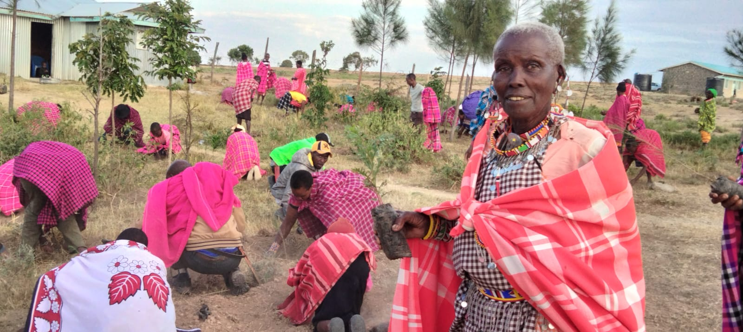
Integrating environment in health programming with Traditional Birth Attendants (Now Mother Companions).

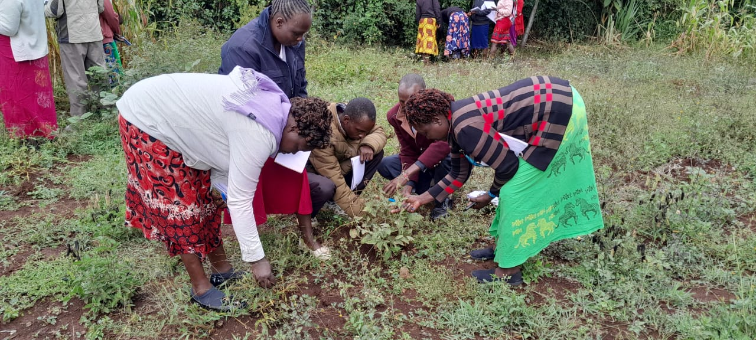
Farmers' Field School Training
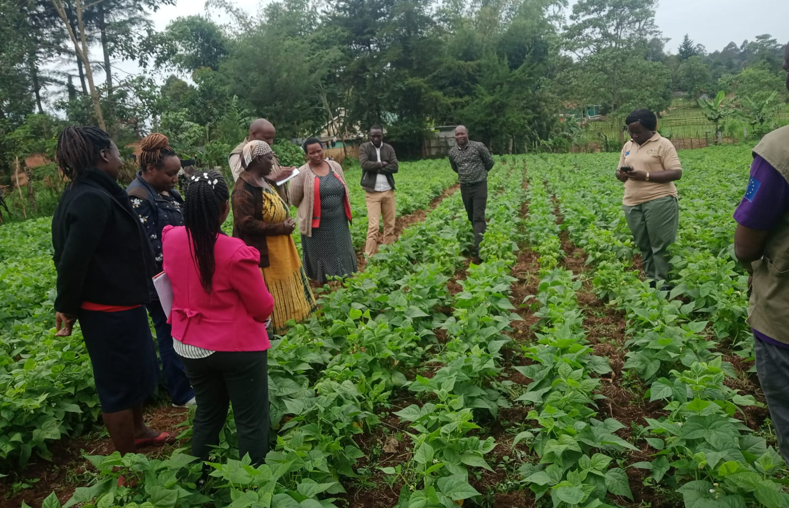
Promoting production and commercialization of new beans’ varieties in Boito demonstration plot.

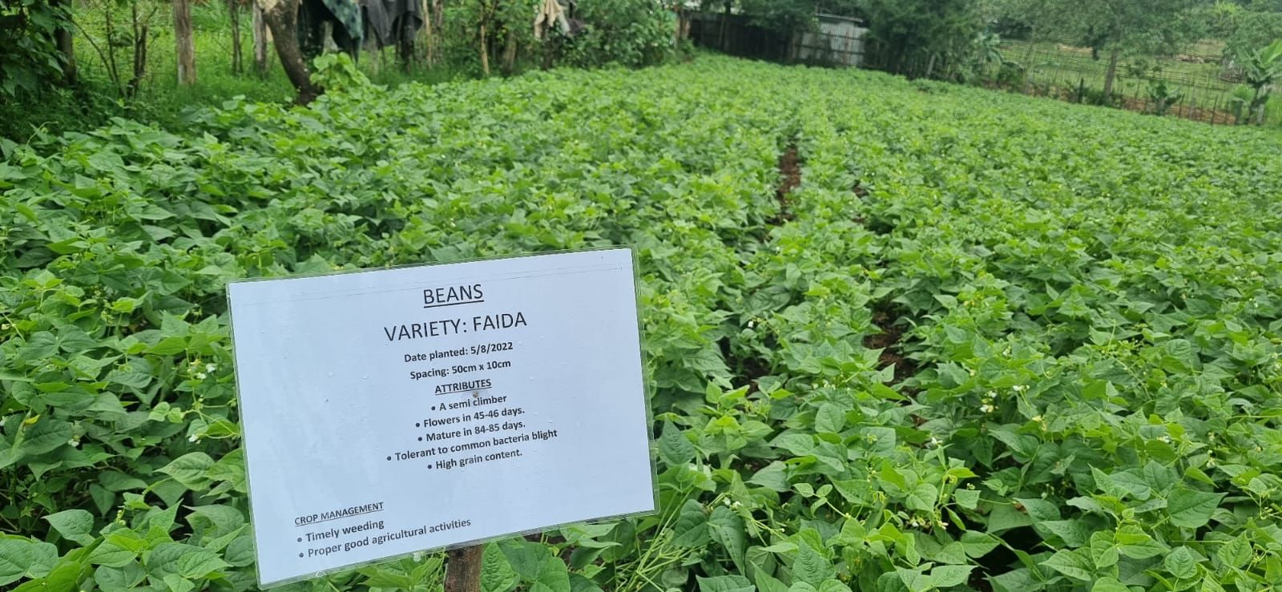
Promoting adoption and commercialization of new bean varieties in Bomet county through KALRO Agri-Fi CS APP project.

