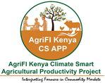
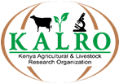


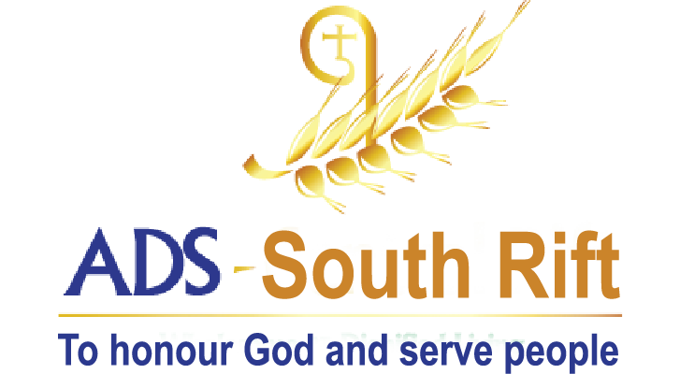

PROJECT SUMMARY
AgriFI Kenya Climate Smart Agricultural Productivity Project
(AgriFI Kenya CS APP)

Scaling up production and commercialization of the new KALRO high nutrient rich and high yielding bean varieties (Angaza,Nyota and Faida) in Bomet County”
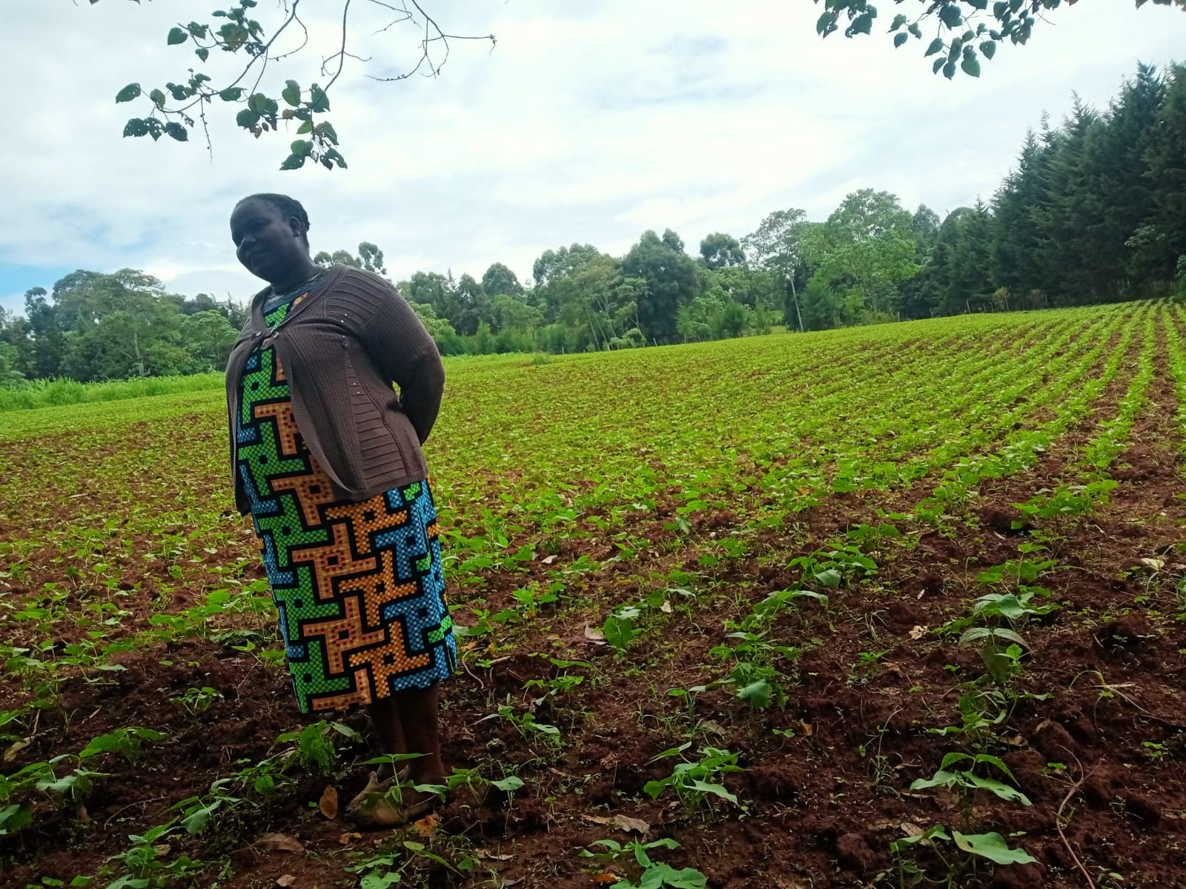
Figure 1: A scale up/ peer farmer from Chemagel Ward, Bomet County in her new 3 acres Nyota beans farm

2.1 Executive summary of the Action
Background information
ADS South rift is one of the partners implementing the Agri-Fi CS APP project Beans value chain in Bomet county. This is a two year project funded by European Union and Government of Kenya through KALRO. The Project titled “Scaling up production and commercialization of the new KALRO high nutrient rich and high yielding bean varieties (Angaza,Nyota and Faida) in Bomet County” targeted to reach 2200 farmers as seed multipliers and as bean farmers in the following areas of Bomet County;
- Sotik sub county: Rongena Manaret and Chemagel wards
- Konoin Sub county: Boito and Kimulot wards
- Bomet Central sub county: Township ward
The overall project objective was “To promote adoption of technologies to improve productivity in beans among 2000 farmers in Bomet County by 2023”. The project’s specific objectives were;
- To promote adoption of technologies to improve productivity in beans among 2000 farmers in Bomet county by 2023.
- To link and integrate farmers to commodity markets to derive economic benefits by 2023.
- To facilitate farmers access to and use of production inputs by 2023.
- To enhance farmers access and derive services from financial institutions by 2023
- To build capacity of farmers and other stakeholders along the bean value chain by 2023

The project implementation model;
The project was implemented through Technology Transfer Model, Business Model and Farmer Field School (FFS) approach . The key components of the approach include working with small farmers’ groups; involving theoretical and practical trainings on demonstration farms and return demonstrations by each of the farmers in their own farms. They implement each of the practical lessons on their farms for each of the lessons learnt. This was then followed by peer influence to transfer the learnt technology. ADS SR established 4 main demo farms in 4 wards (Rongena- Manaret, Chemagel, Kimulot and Boito wards). Due to the distances from the farmers, lead farmers were identified and their farms used as demo sites for the nearby farmers. In total of 8 demo plots were established. ADS SR engaged 5 farmer facilitators who were trained and supported to support farmers in establishing their farms per the bean agronomic guidelines. The MOAL extension officers were also engaged to provide technical support to the farmers in their farms.
Achievements per Objective;
- To promote adoption of technologies to improve productivity in beans among 2000 farmers in Bomet county by 2023:
To begin with ADS SR conducted project sensitization meetings with the MOAL and the engaged the farmers in initial mobilization meetings where they turned up in large numbers in all the 5 targeted wards. The interested farmers attended the initial theory trainings where 2,108 farmers were trained on the bean agronomics. Training needs were assessed among the farmers and consequent capacity support focused on the identified areas of needs. Among the trained farmers 220 farmers attended the practical lessons at the demo sites and 262 farmers were issued with bean seeds for season one. 8 Radio Sessions on two radio stations (Nenyon and Light and Life) were also conducted on the new bean varieties including their agronomics as well as linking them to the project office for access of seeds reaching over 700,000 people. The 262 farmers who adopted the technology in seasons 1 and two were instrumental in peer influence as well as selling seeds to the peers and supporting them through the learnt production skills such as spacing, choice of fertilizers and chemicals. Seed recovery was among the strategies where farmers return equal amounts of seeds issued to them through the project. As at reporting period, 1,609 kgs had been recovered from the farmers, selected, treated and redistributed to new farmers.
As at the reporting period 1,854 farmers had adopted at least one on the bean varieties. Nyota was the most preferred variety due to the quick maturity. However, the farmers later realized that Angaza had a better taste than Nyota and was also more resistant to excess rains therefore had started to take it up.
Farmers adopted other technologies including use of various fungicides and insecticides at various timings to reduce crop infestations by diseases and insects; use of chilli to scare away hares that destroyed the crops; Hermetic bags for bean storage which highly stopped the infestation of the beans by weevils and conservation agriculture.
ADS SR engaged other players including the MOAL, KALRO and Abosi Tophill cooperative in providing capacity and experiences to the new farmers. It also incorporated adoption of the new bean varieties within its ongoing projects especially in FFS and the Child Cantered Community Development Project in Sotik

ii. To facilitate farmers access to and use of production inputs by 2023
During the initial trainings, farmers were taken through the input requirements for beans value chain and the expected production and sales. All the required inputs were identified and costed. The costing of the profit margins was done with each of the farmers groups. All the input needs were identified. ADS SR conducted a county stakeholders meeting that brought together key input suppliers including Kaplomboi and Abosi Top-hill cooperatives for seeds supply, Syngenta for farm chemicals and Yara for fertilizer. Farmers were linked with YARA fertilizers where a trainings were conducted on the proper application of various fertilizers at different stages. Farmers were able to purchase fertilizers as a group at a discounted prices. Syngenta Company were engaged during training and farmers were able to learn on safety use of chemicals, ratio and spraying programs for different crops. The input suppliers were engaged during farmers’ field days where they show cased their products while providing more information to farmers on proper utilization and costs.
Other identified suppliers for seeds include KALRO Kitale and KALRO Njoro who have been key in supplying seeds to the project supplying 670kgs of and 1,350kgs respectively. They both supplied the Nyota variety. ADS SR established a seed store where the recovered seeds are collected, sorted and preserved then redistributed to new farmers. 1,6s09kgs of recovered seeds from the farmers were redistributed to 593 new farmers. It also stocks certified seeds through Abosi Top-hill cooperative where farmers get ease access at the market rates. So far 436kgs of seeds had been sold to 69 farmers through the cooperative.
iii. To link and integrate farmers to commodity markets to derive economic benefits by 2023.
ADS SR together with MOAL and with the support of KALRO identified various link markets. Key among them were the Abosi Top-hill Beans cooperative in Sotik Sub County and Kaplomboi beans cooperative who aggregate and sell the beans to a processor. Others included the nearby schools who receive beans from farmers in exchange for school fees, Suppliers to WFP and the local market places. Farmers were sensitized on available markets with whom a marketing meeting was conducted. The farmers organized themselves in to 2 market groups with an aim of aggregating their beans for a common markets. However, the challenge has been getting reasonable amounts for sale as they prioritize consumption and sell to schools as an exchange for school fees. The two groups identified market monitors to support in monitoring the market trends and prices. More trainings were conducted on market linkages with the Support of Cereals Growers Association where farmers learnt on aggregation for easy marketing and bargaining power since the buyers need to purchase beans in bulk. Farmers representatives from each farmers group visited Abosi Top hill cooperative society where they learnt on how a cooperative is formed, how they Aggregate beans before supplying to the process as a cooperative society. A different group visited Makueni AMUKA Agribusiness HUB to gain more skills on aggregation and marketing.
iv. To enhance farmers access and derive services from financial institutions by 2023
ADS SR linked the farmers to the following financial providers, Kericho Community Development Trust. This provider issues loans but on conditions that the farmer has to make savings with them. Equity bank where farmers were trained on the procedure and qualification to acquire loan as group or individuals and other products. Farmers were also linked to Imarisha SACCO.

Outcomes:
As at the reporting period, 2479 farmers had been reached directly by the project through trainings, sensitization forums and sale of bean seeds. 1,854 of these had adopted the new bean varieties and through the value chain, KES 16,433,565 had been generated through the value chain.
The consumption of the new bean varieties at the household level had increased with 1,854 farmers producing, consuming and selling beans and/or bean seeds. On average, the production of beans increased to 3-4 bags of 90kgs as compared to the previous production of 0.5-2 bags with other bean varieties and without the technical skills. The farmers adopt the learnt production technologies. 31,864 kgs of beans had been produced as at the reporting period.
Farmers were linked to available bean markets and are now selling to the nearby cooperatives at fair and stable prices. Verbal MOUs were reached with between the farmers and the cooperatives to provide stable prices and the farmers to aggregate beans to make collection easier. Aggregation had not been successful but farmer trainings, sensitizations and learning tours to Abosi and to Makueni were conducted on the importance and the process of aggregation. Where the middleman bought their crops from the farm, they provided better prices for these varieties due to their high quality. Other available markets are the schools where the farmers exchange the beans for school fees.
Through the linkage meetings with the input suppliers, farmers have access to quality farm inputs including farm chemicals from Sygenta, seeds from KALRO through Abosi Top Hill and Kaplomboi bean cooperatives and fertilizer from YARA. Through the trainings on seed quality and preparations, the farmers access better quality seeds from fellow peer farmers compared to previous qualities.
100 farmers have also been linked to financial institutions including Equity Bank, Imarisha SACCO and Kericho Community Development Trust Microfinance. Though none of them have accessed bean farming loans, they are now aware of the available sources of funding including their lending terms and conditions. The linkage meetings were ongoing. Farmers are hesitant to take loans as they site they unpredictable production due to the weather challeges.

